Visualization

Cycle 2

Cady Pridgeon

Amee Kivette

Keanna Tennyson

Laura Wilson

### COMP 4710 Senior Design Project #3 Team Orange

Department of Computer Science and Software Engineering

Samuel Ginn College of Engineering, Auburn University

March 25, 2024

Table of Contents

**1. Introduction • Cady Pridgeon 4**

1.1. Project Mission 4

1.2. System Metaphor 4

**2. Previous Development • Amee Kivette, Laura Wilson 4**

**3. Cycle Intent • Cady Pridgeon 5**

**4. Future Work • Keanna Tennyson 6**

**5. User Stories • Cady Pridgeon, Amee Kivette 7**

**6. Design Documentation • Cady Pridgeon 16**

6.1. Architecture 16

6.2. Structure 18

6.3. Interfaces 22

6.4. Justifications of Decisions 26

6.5. Assumptions & Dependencies 26

**7. Management Plan • Cady Pridgeon 27**

7.1. Team Organization 27

7.2. Task Assignments 29

7.3. Development Schedule 30

**8. Risk Mitigation • Cady Pridgeon 30**

**9. Test Documentation • Cady Pridgeon, Amee Kivette 31**

9.1. Testing Plan 31

9.2. Acceptance Tests 31

9.3. Unit Tests 39

9.4. Test Logs 51

**10. Review Logs • Keanna Tennyson, Laura Wilson 54**

**11. Lessons & Challenges • Cady Pridgeon, Amee Kivette 57**

11.1. Lessons 57

11.2. Challenges 58

**12. Sponsor Approval • Cady Pridgeon 60**

**References • Cady Pridgeon 61**

**A. Appendix • Keanna Tennyson, Cady Pridgeon 62**

A.1. Meeting Minutes 62

A.2. Correspondence 69

A.3. Project Resources 72

A.4. Source Code 73

A.5. Version Description 73

A.6. Current Cycle Documents 75

A.7. Previous Cycle Documents 75

# 

# Introduction • Cady Pridgeon

The Alabama Authors of the 19th and 20th Centuries is a digital humanities project created by Dr. Beverley Park Rilett. This online resource provides access to information about Alabama authors and their published literature [1].

## Project Mission

The goal of the team is to enhance the Alabama Authors website with additional data visualizations. At the start of the semester, the only visualization on the project was a literary map. Dr. Rilett requested the addition of a chronology, similar to that of the one on her George Eliot Archive website. Thus, the mission of the Visualization Orange Team is to add a chronology that visualizes over 1,700 authors [1]. Once the team incorporates chronology visualizations into the site, they will proceed to add further visualizations, such as a sunburst or graph data visualizations.

## System Metaphor

Data visualization is a remarkable feature of this project, currently in the form of a literary map and chronology. These visualization components are like a museum exhibit, allowing users to visually explore information before diving deeper into the details. While the map and chronology are the latest visualizations available, there is potential to research additional exhibits to enhance the learnability of the rich information the project holds [1].

# Previous Development • Amee Kivette, Laura Wilson

Development in the Architectural Spike primarily focused on exploring Omeka Classic to become familiar with its capabilities and limitations. Omeka Classic offers several temporal plugins that have different features and functionality to consider. Another crucial aspect of previous development focused on data preparation. The team reviewed the Alabama Authors data with the project sponsor, Dr. Rilett, to build the initial collection. It was necessary to learn the basic application features of Omeka Classic to create a collection with the desired metadata [2].

The primary goal of Cycle 1 was to create an initial chronology prototype with all of the Alabama Authors data entries. To achieve this goal, the team added all Alabama Author data into Omeka Classic. Then, the team researched which data visualization approach to use going forward by creating minimally viable product (MVP) prototypes with each tool. The team identified three plugins, Neatline, Neatline Time, and Timeline, that could produce a chronology within Omeka Classic. By creating low-fidelity prototypes with these plugins, the team gained an understanding of the limitations posed by each plugin. Additionally, to satisfy sponsor needs, the team experimented with D3.js to create a fully customizable visualization. At the end of the cycle, the team delivered two MVP chronology visualizations that are robust, interactive, compliant with sponsor requirements, and compatible with Omeka Classic [2].

# Cycle Intent • Cady Pridgeon

The main objective of Cycle 2 was to expand on the MVP chronology visualizations produced in Cycle 1. At the end of the cycle, the team aims to produce two strong, publishable chronology options using the Neatline plugin and D3.js.

Using the Neatline plugin, a sunburst image will be created to facilitate a heatmap-style visualization along with the Neatline Waypoints widget timeline. Proof of concept has been presented for this solution, but accomplishing a complete visualization may be challenging due to the requirement of tedious data entry. However, between one-fourth and one-third of the data has already been incorporated into the timeline.

The D3.js chronology will be simplified by utilizing the collection data sources within Omeka Classic. After collecting this cleaned data, the visualization will be connected to internal data, providing more consistency between the visualization and the website. Once the data is prepared, utility functions, such as sorting and filtering, will be polished to expand on user functionality. Finally, the chronology will be published on the Alabama Authors website for users to freely access.

Providing two complete chronology exploration tools allows more flexibility and customization for users. This will benefit the overall user experience, as visitors can approach multiple data exploration methods and decide which visualization best suits their needs.

# Future Work • Keanna Tennyson

Going forward, the team plans to research additional visualizations and improvements to incorporate into the website. After researching Omeka Classic plugins for the chronology visualization, the group identified a few tools for graph-based visualizations. These plugins could facilitate further visualizations for the project [1]. Additionally, D3.js provides some interesting visualizations the team could leverage for the project.

The sponsor also mentioned connecting some supplementary data, namely book publications, with the primary data source to generate more advanced, informational visualizations. The team has begun researching possibilities for more complex visualizations and recorded these new objectives in additional user stories.

Accessibility and intuitive user experience are two priorities of the team. Since the primary target audience is professors and humanities academics, the user interface must be straightforward yet comprehensive. Subject matter experts will be very interested in the website content but will also desire uncomplicated navigation. Thus, the team aims to conduct usability testing to ensure a wholly accessible interface that is Web Content Accessibility Guidelines (WCAG) 2.2 AA compliant [1].

# User Stories • Cady Pridgeon, Amee Kivette

**Table 1. User Story 1.0 Chronology Data Visualization**

| **1.0 Chronology Data Visualization** | |
| --- | --- |
| Summary | As a user, I want to view authors on the Alabama Authors website in a chronology/timeline format to better explore and learn about the authors. |
| Description | Currently, the only visualization on the Alabama Authors website is a literary map. While this heatmap data visualization provides additional specific geographical context to the authors, a temporal visualization would also be interesting. This type of visualization enables users to explore the periods authors were alive and popular during to facilitate education, understanding, and research of the authors. |
| Planned Hours | Cycle: 0  Total: 40 |
| Actual Hours | Cycle: 2  Total: 27 |
| Coder | Cady Pridgeon, Amee Kivette |
| Tester | Cady Pridgeon |
| Reviewer | Cady Pridgeon, Amee Kivette, Keanna Tennyson, Laura Wilson |
| Status | Completed |

**Table 2. User Story 1.1 Chronology Data Visualization**

| **1.1 Chronology Data Visualization** | |
| --- | --- |
| Summary | As a user, I want to be able to see author names, birth years, death years, and pictures when I hover over or select nodes to quickly learn about the author without having to navigate to their details page. |
| Description | Allowing users to see important information at a glance on the visualization supports their exploration and search of users. It also helps to differentiate nodes within the visualization. |
| Planned Hours | Cycle: 10  Total: 10 |
| Actual Hours | Cycle: 4  Total: 7 |
| Coder | Cady Pridgeon, Amee Kivette |
| Tester | Cady Pridgeon |
| Reviewer | Cady Pridgeon, Amee Kivette, Keanna Tennyson, Laura Wilson |
| Status | Completed |

**Table 3. User Story 1.2 Chronology Data Visualization**

| **1.2 Chronology Data Visualization** | |
| --- | --- |
| Summary | As a user, I want to be able to interact with author nodes on the visualization to access their details page, allowing me to quickly learn more about authors directly from the chronology. |
| Description | There are detailed pages for each author in the database, so it would support research and education about authors by permitting users to access these informative pages straight from a visualization. The current literary map supports this functionality. |
| Planned Hours | Cycle: 10  Total: 10 |
| Actual Hours | Cycle: 3  Total: 6 |
| Coder | Cady Pridgeon, Amee Kivette |
| Tester | Cady Pridgeon |
| Reviewer | Cady Pridgeon, Amee Kivette, Keanna Tennyson, Laura Wilson |
| Status | Completed |

**Table 4. User Story 1.3 Chronology Data Visualization**

| **1.3 Chronology Data Visualization** | |
| --- | --- |
| Summary | As a user, I want to be able to filter the visualization based on criteria, such as birth years and names, to customize my exploration of relevant information. |
| Description | Including filtering functionality better equips users for efficient data exploration. Without it, users may feel frustrated or experience cognitive overload if they are unable to access information of interest quickly and effectively. |
| Planned Hours | Cycle: 5  Total: 15 |
| Actual Hours | Cycle: 2  Total: 5 |
| Coder | Cady Pridgeon |
| Tester | Cady Pridgeon |
| Reviewer | Cady Pridgeon, Amee Kivette, Keanna Tennyson, Laura Wilson |
| Status | In Progress |

**Table 5. User Story 1.4 Chronology Data Visualization**

| **1.4 Chronology Data Visualization** | |
| --- | --- |
| Summary | As a user, I want to be able to export my visualization to keep for my records to conduct research or simply save my findings. |
| Description | Being able to quickly export a complex visualization into an image or PDF supports users in research and grants them a way to save progress after utilizing visualizations on the website. |
| Planned Hours | Cycle: 0  Total: 10 |
| Actual Hours | Cycle: -  Total: - |
| Coder | - |
| Tester | - |
| Reviewer | - |
| Status | Not Started |

**Table 6. User Story 1.5 Chronology Data Visualization**

| **1.5 Chronology Data Visualization** | |
| --- | --- |
| Summary | As a user, I want to view all of the Alabama authors from the 19th and 20th centuries to gain a complete picture of the literary landscape from this area and time. |
| Description | Currently, the website includes 150 authors in its literary map visualization and detail pages. However, there are around 1,500 data entries for authors from this time, so it is important to include these additional data points for completeness. |
| Planned Hours | Cycle: 0  Total: 5 |
| Actual Hours | Cycle: 0  Total: 3 |
| Coder | Cady Pridgeon |
| Tester | Cady Pridgeon, Amee Kivette |
| Reviewer | Cady Pridgeon, Amee Kivette, Keanna Tennyson, Laura Wilson |
| Status | Completed |

**Table 7. User Story 1.6 Chronology Data Visualization**

| **1.6 Chronology Data Visualization** | |
| --- | --- |
| Summary | As a user, I want to be able to access the Alabama Authors website from any device, such as a computer, tablet, or phone, and experience an accessible data visualization. |
| Description | The data visualization should be responsive, supporting users from any device, including a mobile phone. |
| Planned Hours | Cycle: 0  Total: 10 |
| Actual Hours | Cycle: 1  Total: 1 |
| Coder | Cady Pridgeon |
| Tester | Cady Pridgeon |
| Reviewer | - |
| Status | In Progress |

**Table 8. User Story 1.7 Chronology Data Visualization**

| **1.7 Chronology Data Visualization** | |
| --- | --- |
| Summary | As a user, I want to experience an accessible user interface on the Alabama Authors website to ensure my abilities do not interfere with viable interactions on the website. |
| Description | Color contrast, tab index, and verbiage are a few aspects that make an interface accessible and inclusive. It is crucial that anyone, regardless of their abilities, should be able to access and navigate the website and visualizations with ease. |
| Planned Hours | Cycle: 2  Total: 10 |
| Actual Hours | Cycle: 2  Total: 2 |
| Coder | Cady Pridgeon |
| Tester | Cady Pridgeon, Amee Kivette |
| Reviewer | - |
| Status | In Progress |

**Table 9. User Story 1.8 Chronology Data Visualization**

| **1.8 Chronology Data Visualization** | |
| --- | --- |
| Summary | As a user, I want to view only the 150 completed Alabama Authors found on the website on the chronology to bring improved alignment and consistency to my research and exploration experience. |
| Description | Previously, the D3.js chronology visualization utilized the 1700 author data entries, even though these authors were not published on the website. To keep the visualization and website more consistent, the Author 150 view would use the author collection data from the website. |
| Planned Hours | Cycle: 10  Total: 10 |
| Actual Hours | Cycle: 16  Total: 16 |
| Coder | Cady Pridgeon, Keanna Tennyson |
| Tester | Cady Pridgeon |
| Reviewer | Cady Pridgeon, Amee Kivette, Keanna Tennyson, Laura Wilson |
| Status | Completed |

**Table 10. User Story 2.0 Author Details Page**

| **2.0 Author Details Page** | |
| --- | --- |
| Summary | As a user, I want to view an author's date of birth and date of death on their details page to quickly remember the period they lived through. |
| Description | While users can view an author's date of birth on data visualizations, their birth date and death date are missing from their detail page. This could frustrate users by creating an inconsistency in data availability over various pages on the site. |
| Planned Hours | Cycle: 0  Total: 10 |
| Actual Hours | Cycle: -  Total: - |
| Coder | - |
| Tester | - |
| Reviewer | - |
| Status | Discarded |

**Table 11. User Story 3.0 Calendar Wheel Data Visualization**

| **3.0 Calendar Wheel Data Visualization** | |
| --- | --- |
| Summary | As a user, I want to view publications from the Alabama Authors Book List Collection on an interactive calendar wheel to temporally explore the available data. |
| Description | An interactive calendar wheel visualization would enable users to access specific time periods to identify and analyze the associated publications. This would facilitate the education, understanding, and research of the publications. |
| Planned Hours | Cycle: 5  Total: 5 |
| Actual Hours | Cycle: 3  Total: 3 |
| Coder | Amee Kivette, Laura Wilson |
| Tester | Amee Kivette |
| Reviewer | - |
| Status | Completed |

**Table 12. User Story 3.1 Calendar Wheel Data Visualization**

| **3.1 Calendar Wheel Data Visualization** | |
| --- | --- |
| Summary | As a user, I want to view the publication densities of each time on the calendar wheel as a heat map to visually interpret and interact with the data. |
| Description | A heat map of the publication densities would provide a comprehensive view of the magnitude of the collection throughout the decades of the 19th and 20th centuries. |
| Planned Hours | Cycle: 10  Total: 20 |
| Actual Hours | Cycle: 6  Total: 6 |
| Coder | Amee Kivette, Laura Wilson |
| Tester | Amee Kivette |
| Reviewer | - |
| Status | In Progress |

**Table 13. User Story 3.2 Calendar Wheel Data Visualization**

| **3.2 Calendar Wheel Data Visualization** | |
| --- | --- |
| Summary | As a user, I want to be able to interact with publication items on the visualization to access their details page, allowing me to quickly learn more about publications directly from the chronology. |
| Description | There are detailed pages for each publication in the database, so it would support research and education about publications by permitting users to access these informative pages straight from a visualization. |
| Planned Hours | Cycle: 5  Total: 5 |
| Actual Hours | Cycle: 2  Total: 2 |
| Coder | Amee Kivette, Laura Wilson |
| Tester | Amee Kivette |
| Reviewer | - |
| Status | Completed |

**Table 14. User Story 3.3 Calendar Wheel Data Visualization**

| **3.3 Calendar Wheel Data Visualization** | |
| --- | --- |
| Summary | As an administrator, I want to be able to manage the chronology/timeline data visualization with Omeka Classic to avoid issues with GitHub repository connections. |
| Description | Sometimes data visualizations are connected to the digital humanities websites by hosting the visualization on a GitHub repository and displaying the result on the website with an iframe. However, this is a frustrating solution for site administrators, since they often run into permissions and security restrictions. To prevent this, we must create our visualization using plugins supported by Omeka Classic. |
| Planned Hours | Cycle:  Total: |
| Actual Hours | Cycle: 1  Total: 15 |
| Coder | Amee Kivette, Laura Wilson |
| Tester | Amee Kivette, Laura Wilson |
| Reviewer | Cady Pridgeon, Amee Kivette, Keanna Tennyson, Laura Wilson |
| Status | Completed |

**Table 15. User Story 4.0 Birth Date Data**

| **4.0 Birth Date Data** | |
| --- | --- |
| Summary | As a user, I want to view an author's birth and death dates instead of birth and death years on visualizations to get a complete picture of the author's information. |
| Description | Only the author's birth and death years are collected and stored in the data. However, birth dates could potentially be scraped from descriptions to generate a more complete profile for each author. |
| Planned Hours | Cycle: 0  Total: 20 |
| Actual Hours | Cycle: -  Total: - |
| Coder | - |
| Tester | - |
| Reviewer | - |
| Status | Discarded |

**Table 16. User Story 5.0 Sunburst Data Visualization**

| **5.0 Sunburst Data Visualization** | |
| --- | --- |
| Summary | As a user, I want to view an author by century and then also explore the author’s publications by year to gain a better understanding of the granular temporal significance of their life and works. |
| Description | A sunburst-style D3.js visualization could be used to bridge the gap between the two Alabama Authors data collections: authors and books. This can further data exploration and provide users with additional mediums for diving into literary history. |
| Planned Hours | Cycle: 10  Total: 20 |
| Actual Hours | Cycle: 5  Total: 5 |
| Coder | Cady Pridgeon |
| Tester | - |
| Reviewer | - |
| Status | In Progress |

# Design Documentation • Cady Pridgeon

## Architecture

This project uses Omeka Classic and Reclaim Hosting for management and hosting. Omeka Classic is a content management system (CMS) for archives and educational collections. This is where site administrators can go to add, update, and remove data. Since the primary user group for this website is academics in the humanities, it is user-friendly and not overly technical. Reclaim Hosting facilitates web hosting for educational institutions. This is where the website design controls are located [1].

The primary interactions in this project are users with the data through Omeka Classic visualizations, the data with Omeka Classic, Omeka Classic with Reclaim Hosting, and administrators with the data. Within Omeka Classic, interactions between the data and plugins facilitate data visualization [1].

There is a secondary interaction between GitHub Pages and Omeka Classic to support external visualizations. To generate advanced interactive visualizations, HTML, CSS, JavaScript, and D3.js were utilized to create a chronology visualization. This custom-coded visualization is uploaded to a personal GitHub and then hosted on GitHub Pages. This visualization is embedded into an Omeka Classic Simple Page using an iframe. While this solution is not ideal, it does bring important and complex functionality to the Alabama Authors visualization offerings.

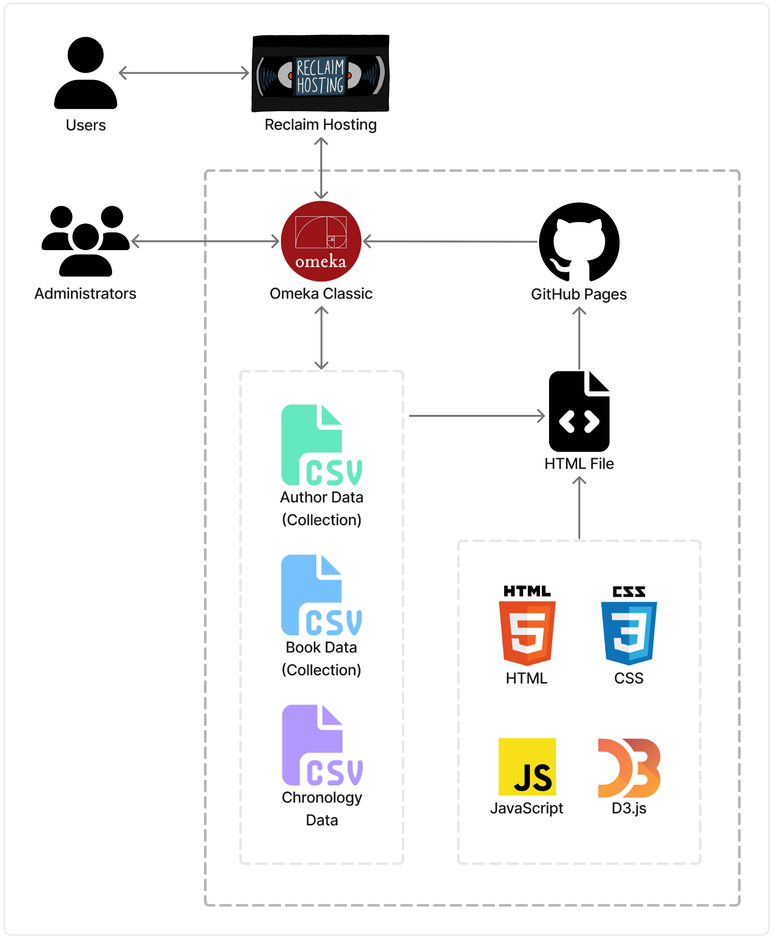

**Figure 1. Architecture Diagram: Technology Flow Chart**

## Structure

A team of researchers has been collecting and refining the Alabama Author dataset, bringing the number of author entries to over 1700. Most of the data used within the project originates from this document. Currently, the data is stored in a spreadsheet on Auburn Box [2].

The original collection of data contains the following fields [2]:

* Author_Last_Name_First_Name: “Last name, first name” (all caps)
* Author_Portrait_Link: Link to author image on Auburn Box
* Author_First_Name_Last_Name: “First name last name”
* Author_Pseudonym_Name: “Pseudonym”
* Author_Dates: Author lifespan, “Birth year-death year”
* City: Associated city
* County: Associated county
* Place_Of_Education: Associated education location
* Birth_Place: Associated place of birth
* Adult_Residence: Associated location of adult residence
* Place_Of_Death: Associated place of death
* Author_Biography: Short author description/biography
* Source: Referenced source(s)
* Book_Publications: Published books
* Book_Publications_Post_2000: Published works after 2000
* Other_Publications: Any other published works

The following fields were added to facilitate chronology data visualizations [2]:

* Birth_Date: Birth year, extracted from Author_Dates
* Death_Date: Death year, extracted from Author_Dates
* Lifespan: Years lived, calculated from Birth_Date and Death_Date
* Author_First_Name_Last_Name_Author_Dates: Display name, created by concatenating Author_First_Name_Last_Name and Author_Dates
* New_Date: Author_Dates in a new format, including January 1 as placeholder month and day for each Birth_Date and Death_date, concatenated with a “/” between
* Page_Link: Link to author details page
* Image_Name: File name of author image

This spreadsheet can be converted into a comma-separated values (CSV) file for data processing. On Omeka Classic, data can be stored in collections, which utilize Dublin Core for categorization and organization across the site. Dublin Core defines metadata items within collections to assist in describing each field [2].

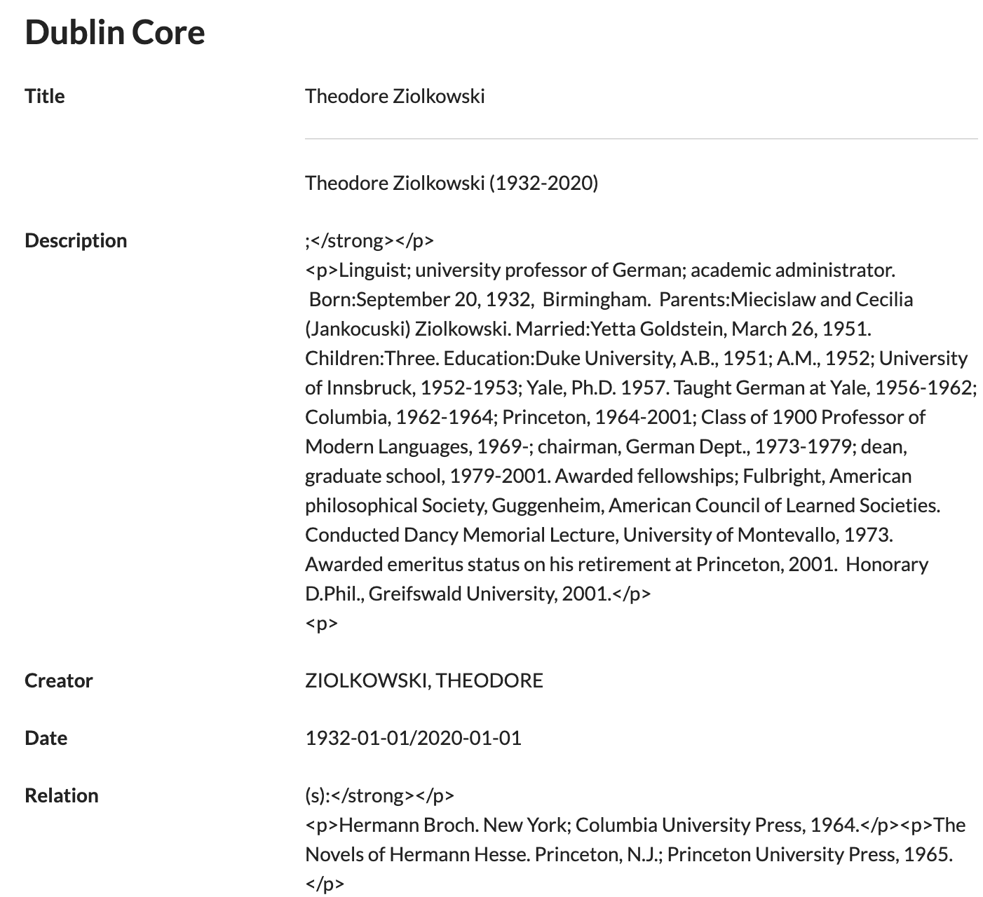

**Figure 2. Sample Author Dublin Core Metadata Fields**

Most of the data field to metadata category assignments are straightforward, but it can be beneficial to gain an understanding of the Dublin Core metadata definitions and intended usages. For this project, the identifier field is used to create relations between items, so the team was advised to refrain from utilizing this metadata attribute [2]. Two of the Omeka Classic collections, the AL Author Collection and AL Book Collection, were exported to facilitate external data visualizations.

After attaching proper metadata tags to each data field, Omeka Classic stores the data in a collection. From a collection, author objects and respective attributes can be passed into internal pages and plugins. Collections can be displayed in a tabular format with sort features. Additionally, collections can be parsed within Omeka Classic plugins, which often provide data visualization capabilities [2]. For external uses, the collections can be exported as CSV files and parsed using JavaScript to produce complex visualizations. These outside visualizations can then be hosted and incorporated back into Omeka Classic using an iframe embedding within a Simple Page or Exhibit.

The D3.js chronology visualization currently utilizes the following fields from the AL Author Collection:

* “Dublin Core:Title”: “First name last name”
* “Dublin Core:Date”: Author lifespan, “Birth year-death year”
* “Item URI”: Link to author details page
* “file”: Array of links to author images hosted on Omeka Classic

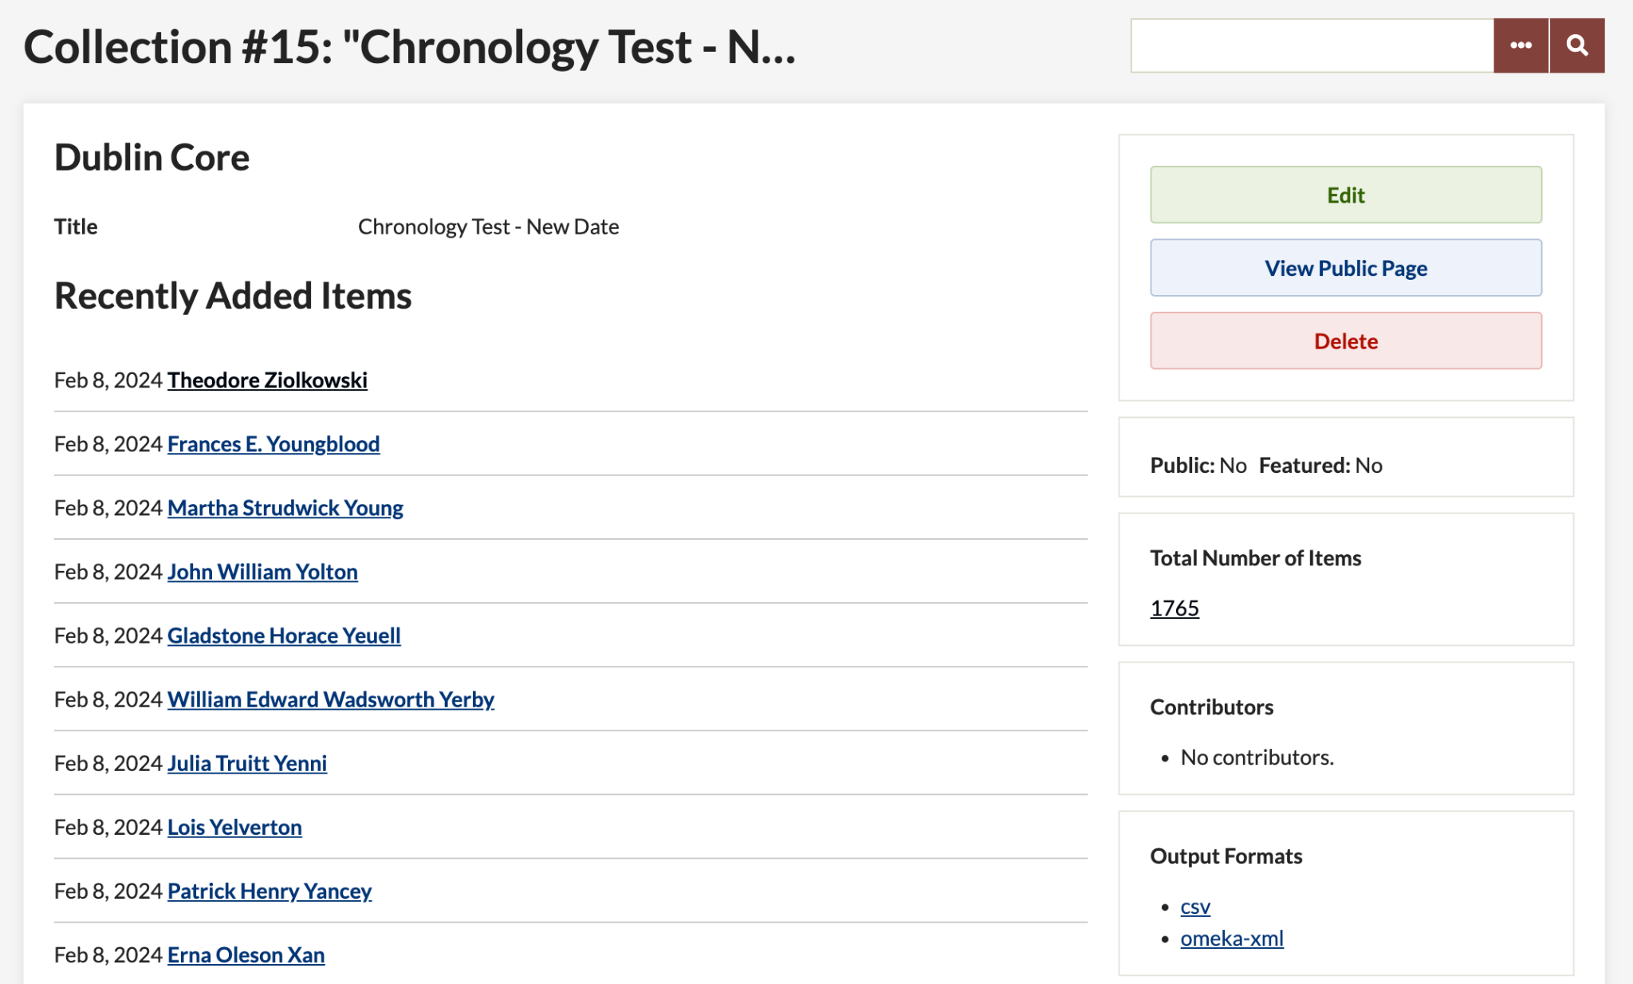

**Figure 3. Chronology Test Collection on Omeka Classic**

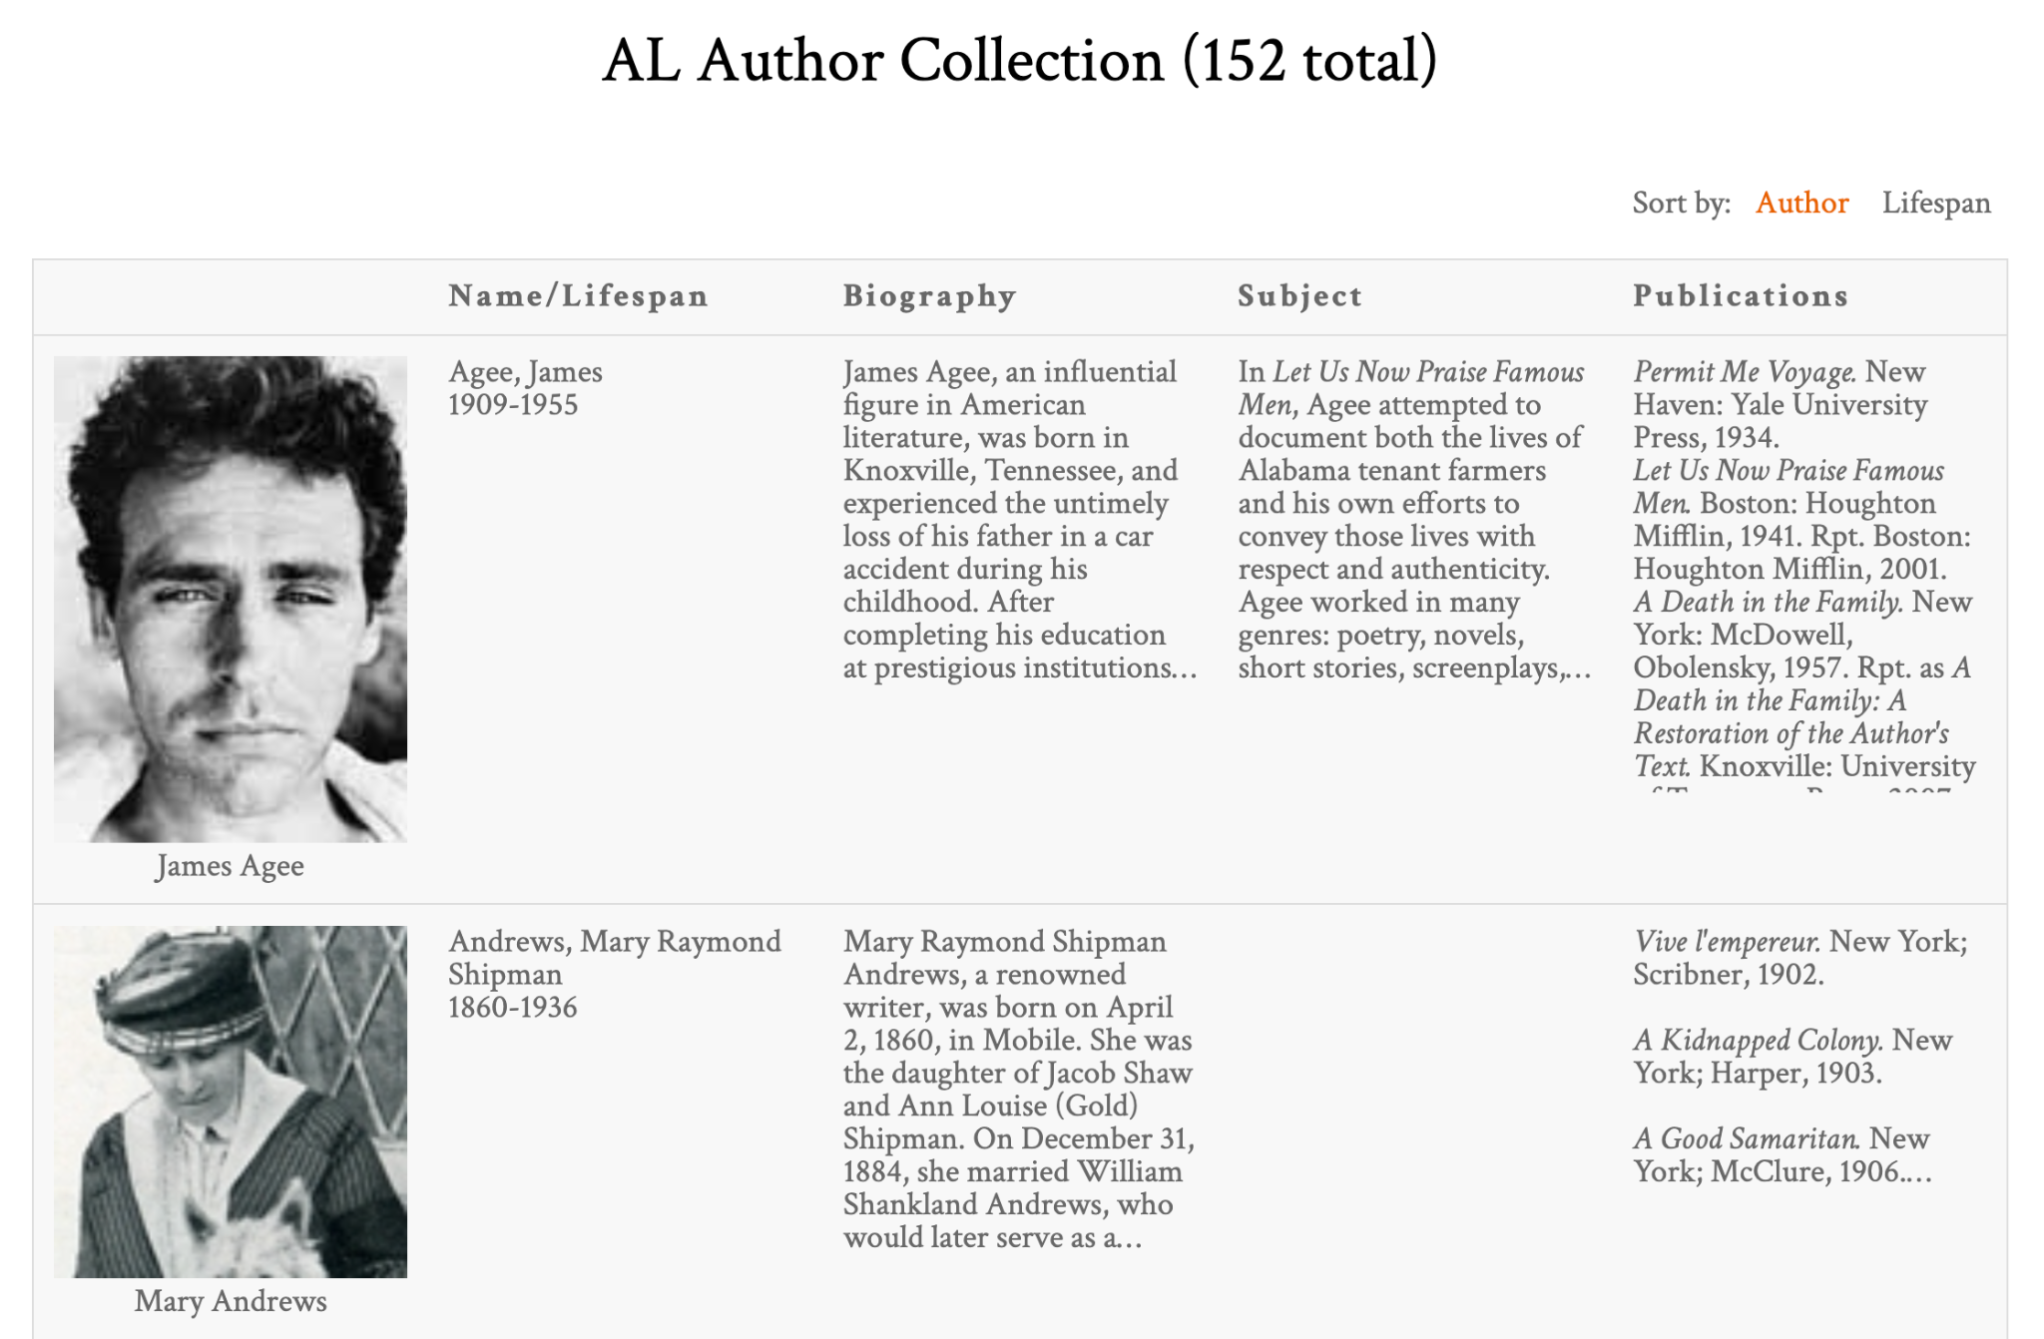

**Figure 4. Alabama Author Collection on Page with Tabular Format**

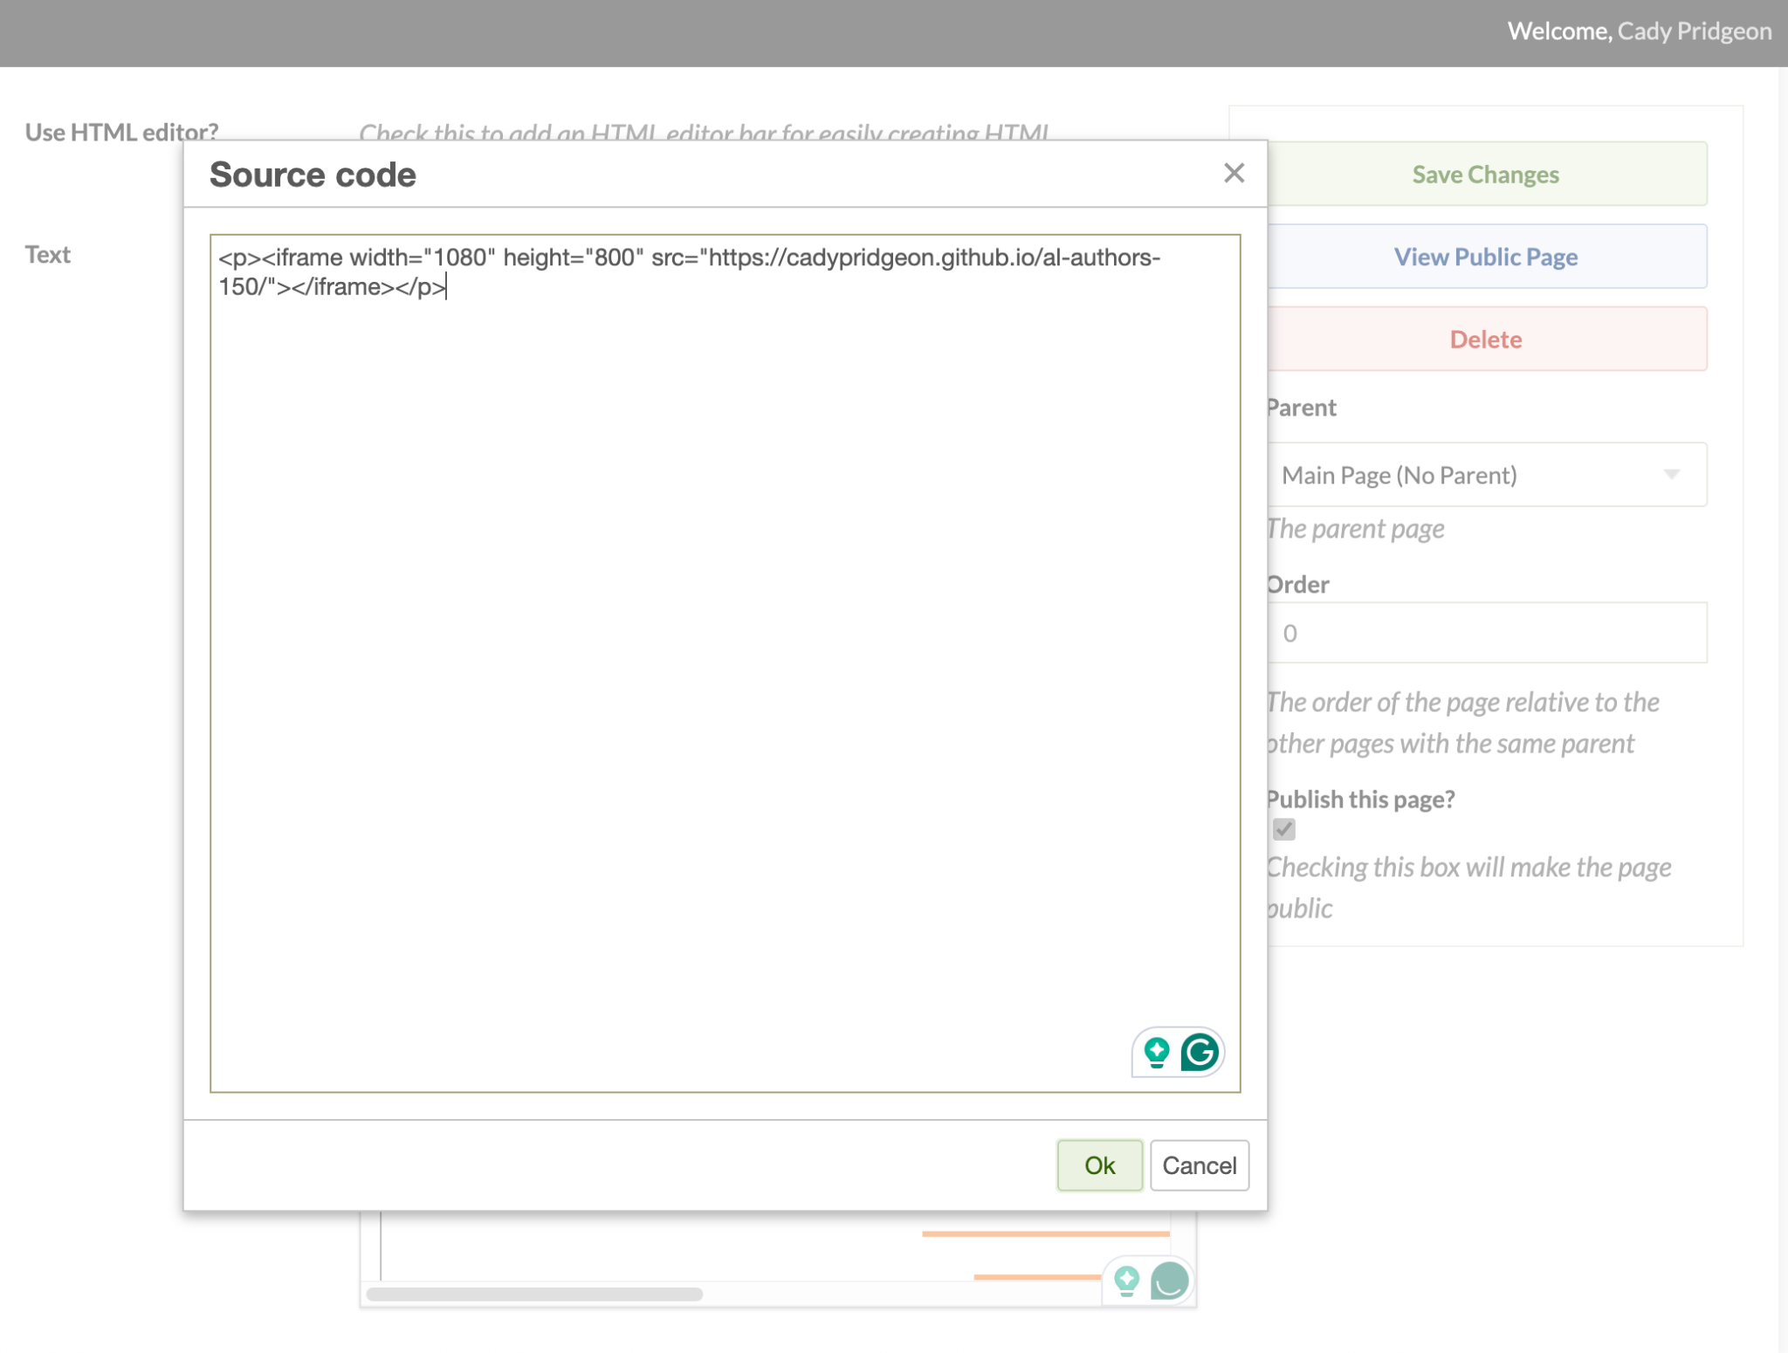

**Figure 5. Alabama Author Simple Page Iframe Embedding**

## Interfaces

Omeka Classic allows the use of supported plugins to facilitate data parsing and visualization on a website. During team research, the following plugins were identified as possible means by which a chronology could be created within Omeka Classic [1]:

* Neatline Time
* Timeline
* Neatline

The Neatline Time plugin provides a very basic interface, displaying thin bars for each author instance on the timeline. The time axis can be centered on a specified date, but it cannot be specified any further. Due to this constraint, navigation of the visualization may cause user frustration. The plugin maintains a granular view of the data, which minimizes the impact of the number of author data entries collected. It provides basic author information, such as author name, lifespan, description, and link. Thus, it provides no unique functionality that sets it apart from similar plugins [2].

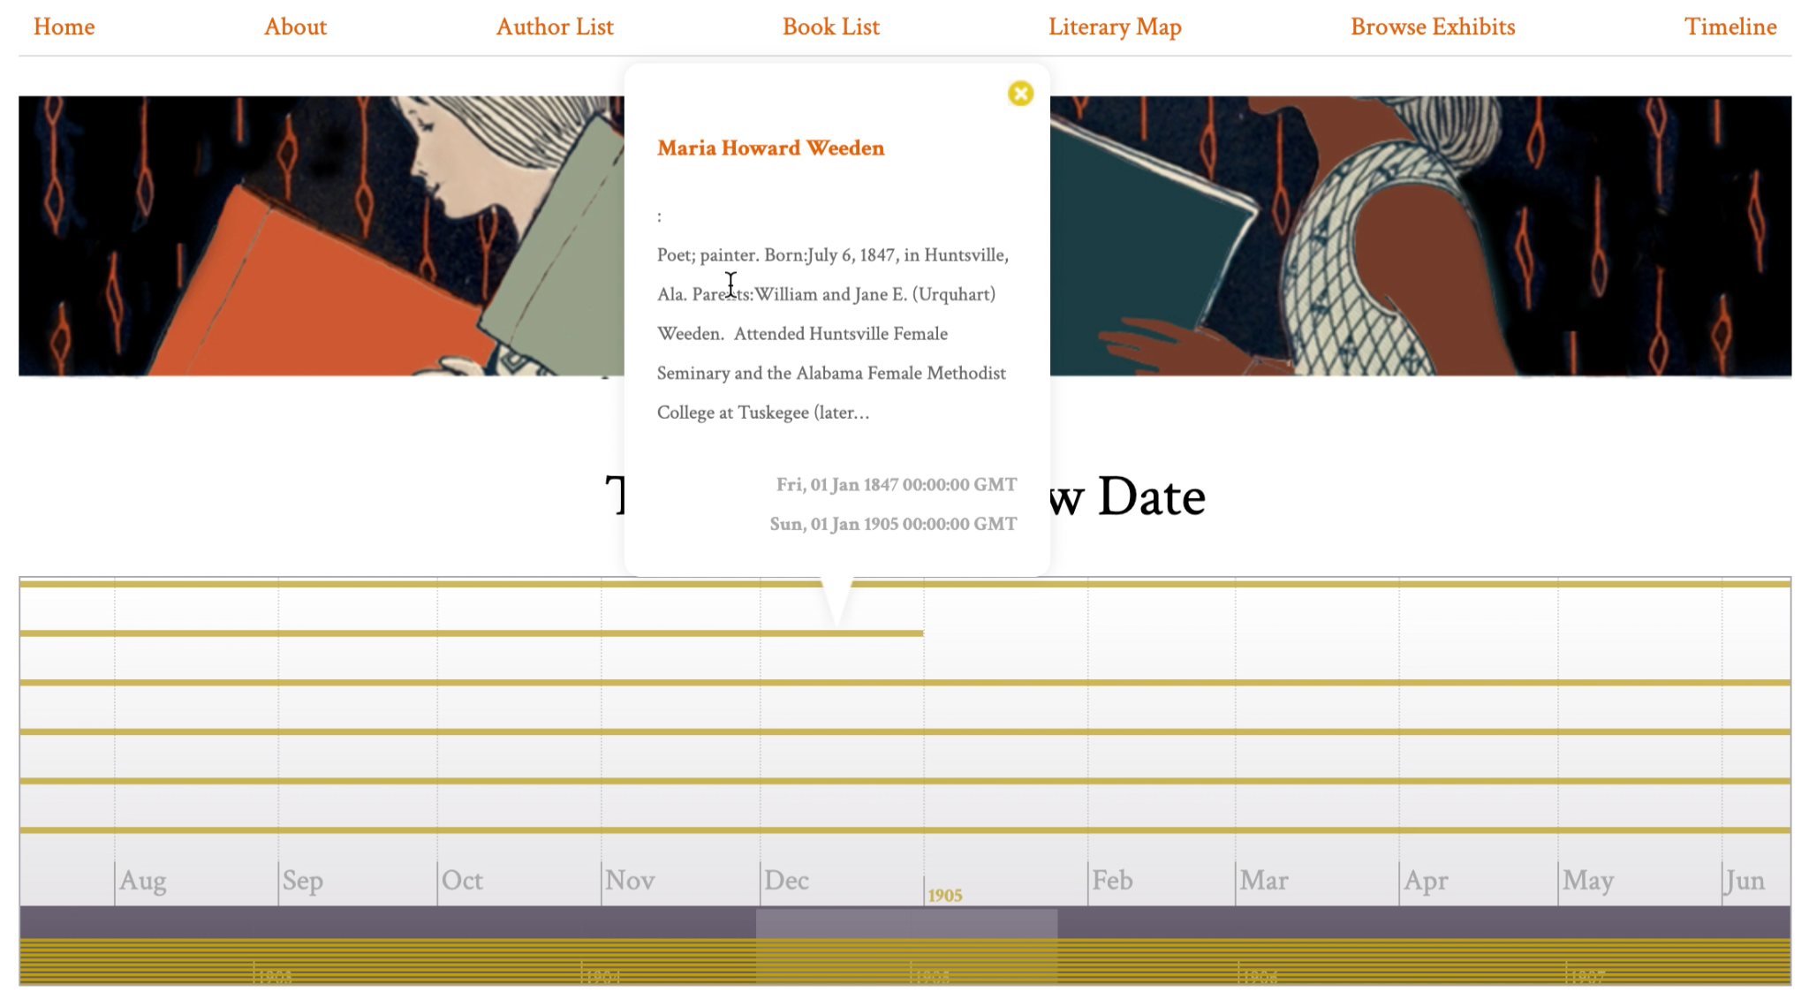

**Figure 6. Omeka Classic Neatline Time Plugin Chronology Visualization**

The Timeline plugin provides an interesting interface. The timeline portion of the visualization resembles the Neatline Time plugin, but it does provide more functionality. It has four navigation help options, including zoom in, zoom out, jump to front, and jump to back. Additionally, when a user clicks on an author span, instead of populating a tooltip, the author information shows in the space above the timeline. This allows for increased focus on the author, as well as more room for detailed information. The plugin also contains arrows at the top, allowing for navigation to the next or previous author, based on birth year. However, the primary drawback to this plugin is its latency. This plugin is the slowest of the three due to its navigation features [2].

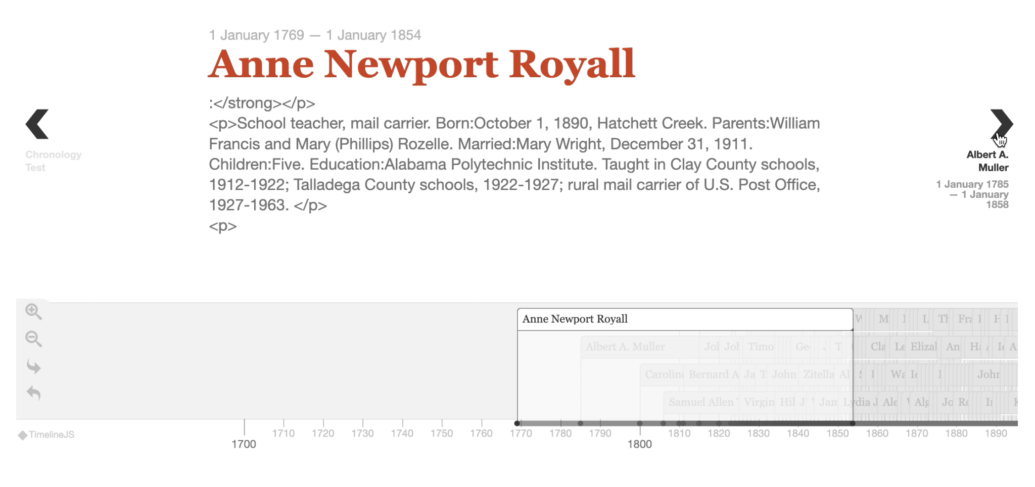

**Figure 7. Omeka Classic Timeline Plugin Chronology Visualization**

The Neatline plugin provides more functionality within its interface, allowing users to click on a predefined area of an image to zoom in and explore. It is currently used for the Literary Map on the Alabama Authors website because of this feature. When clicking on authors, the information listed is customizable, allowing for increased specification of the system. A heatmap-style solution was proposed, since a sunburst chart may best complement the plugin’s image support. With its increased interactivity and personalization, it seems promising for the chronology. However, all information available on the visualization must be entered manually. This includes any author information, such as their image and link, and developers would have to manually activate the SIMILE Waypoints Timeline widget for each entry [2].

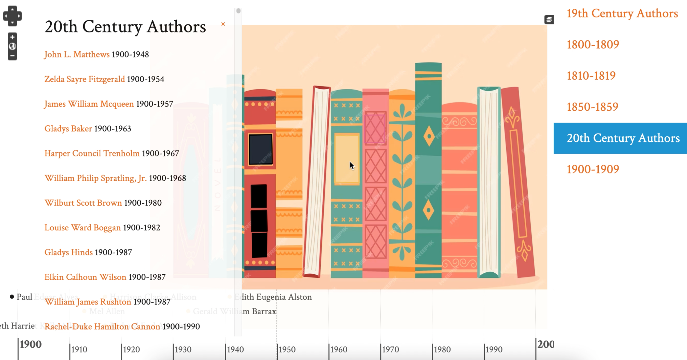

**Figure 8. Omeka Classic Neatline Plugin Chronology Visualization**

Two additional plugins, AvantRelationships and Archiviz, were identified for possible data visualization in a graphical format. If time permits, these could be interesting visualization options to increase data exploration capabilities [1].

One external data visualization tool was explored for experimentation purposes. The project sponsor expressed interest in seeing robust and interactive visualizations, even if they needed to be hosted externally and interfaced with Omeka Classic. The team decided to investigate D3.js, a JavaScript library for creating interactive data visualizations [2]. The D3.js chronology visualization is in a zoomable bar chart style, with author information on a hover state, clickable bars, filter functionality, and sort functionality. Currently, the visualization interfaces with Omeka Classic through an iframe embedding within a Simple Page, but it could be possible to host the visualization on Reclaim Hosting if necessary.

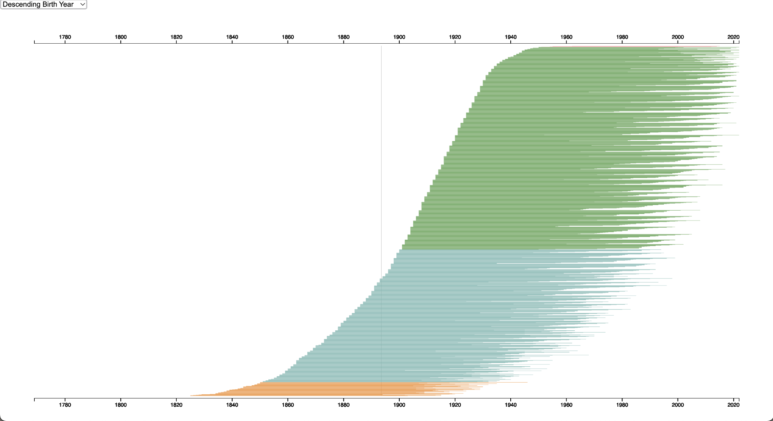

**Figure 9. Initial D3.js Bar Chart Chronology Visualization**

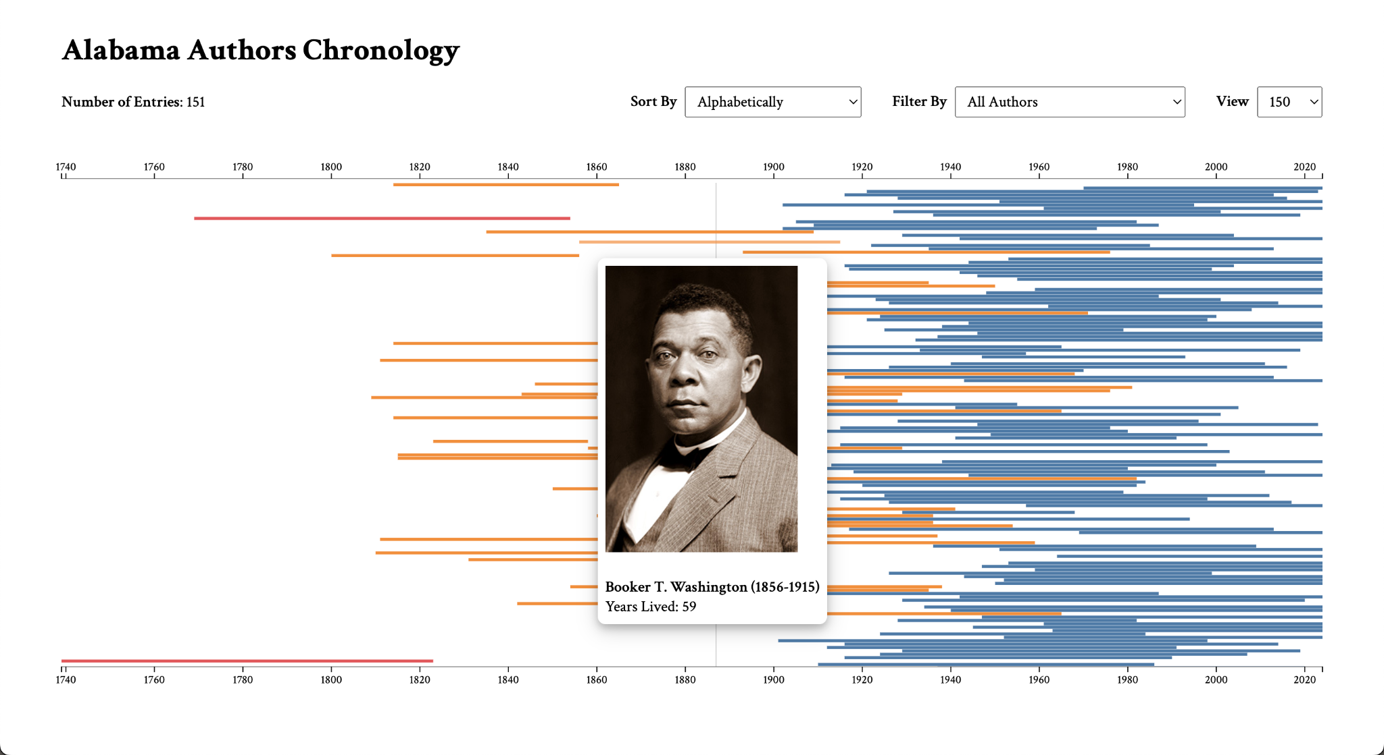

**Figure 10. Current D3.js Bar Chart Chronology Visualization**

Currently, the team is experimenting with another D3.js visualization for zoomable sunburst capabilities. The sponsor mentioned the possibility of creating a visualization that would display author information and their book publications, and an interactive sunburst could be a solution. However, the team is still in the early research stages regarding this tool.

## Justifications of Decisions

Most of the project design decisions were previously established. Omeka Classic and Reclaim Hosting have been used for prior projects, so the project sponsor required that the team utilize this architecture for Alabama Authors [2].

During the initial meeting, the sponsor advised against hosting visualizations on GitHub repositories and displaying them on the website using an iframe. This solution was suggested to be avoided since it causes permissions and security issues for administrators. Thus, the team initially decided to move forward with plugins supported internally within Omeka Classic [2].

However, these plugins provided rudimentary functionality, so with sponsor approval, the team decided to explore an external option. Since D3.js provided the functionality the team’s sponsor was looking for, the iframe embedding solution was enthusiastically supported by the project sponsor. Both the Neatline plugin and D3.js solutions were pursued by the project to provide greater flexibility and user control over preferred visualizations.

## Assumptions & Dependencies

This project assumes that the primary data sources are the Alabama Authors CSV file, AL Author Collection CSV file, and AL Book Collection CSV file. Utilizing exported collection data can facilitate greater consistency between the website data and visualization data, so the team shifted towards more heavily relying on the collection data.

The capabilities of the chronology visualization depend on the flexibility and comprehensiveness of the plugins available on Omeka Classic. Since the sponsors initially advised avoiding creating a visualization hosted on GitHub, the team was limited to the capabilities available on Omeka Classic [1]. Now, as the sponsors determined that hosting on GitHub is acceptable, the team was able to move forward with the D3.js solution. However, keeping security and permission concerns in mind, this external solution may not be optimal in the long-term scope of the project.

# Management Plan • Cady Pridgeon

## Team Organization

For team communication, group messages, email, and Zoom are utilized. These mediums of communication allow for quick discussion of project matters. To coordinate with Dr. Rilett, the team uses email, Zoom, and in-person meetings to discuss weekly progress and tasks. To organize and schedule team meetings, Microsoft Excel is used. The cycle status reports also help the team with productivity and time management [1].

To manage user stories and tasks, a Kanban taskboard is leveraged. The team has a shared workspace on Notion where an Agile-style development process is carried out [1].

For the code base, Omeka Classic is used for content management and data import. Reclaim Hosting houses the user interface design and controls [1]. GitHub and GitHub Pages are utilized to manage and host the external D3.js visualization.

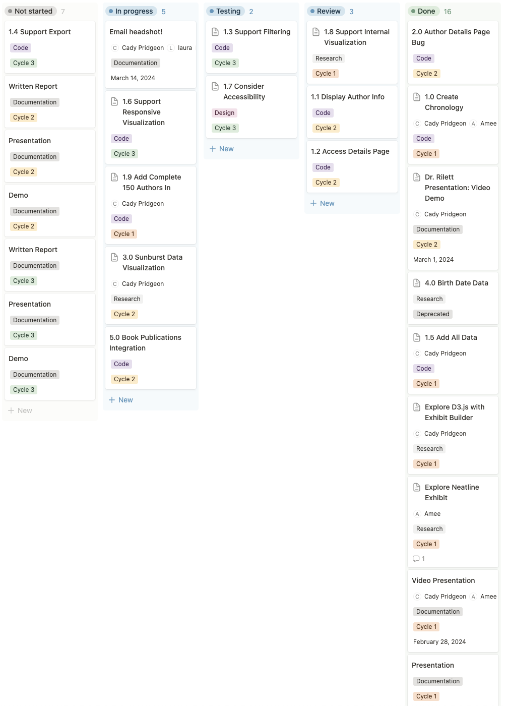

**Figure 11. Notion Kanban Board for Task Management**

## Task Assignments

The team established some general roles for each member during the Architectural Spike. These roles are as follows [2]:

* Cady Pridgeon: Deliverables Coordinator & Developer
* Amee Kivette: Developer
* Keanna Tennyson: Meeting Coordinator
* Laura Wilson: Reviewer

During Cycle 1, the team divided up tasks as follows [2]:

* Cady Pridgeon: Finish cleaning and uploading author data to Omeka Classic, experiment with Neatline Time and Timeline plugins, create D3.js visualization
* Amee Kivette: Create Neatline visualization, create sample sunburst chart, review cleaned author data
* Keanna Tennyson: Organize team meetings, take meeting minutes, review visualizations
* Laura Wilson: Review visualizations, explore any outlying visualization options

During Cycle 2, the team divided up tasks as follows:

* Cady Pridgeon: Create D3.js chronology visualization with exported Omeka Classic collection data, add utility functionality, such as sorting, filtering, and switching views, clean up the look and responsiveness of visualization using accessibility testing, begin exploring book publication visualization
* Amee Kivette: Continue exploring Neatline heatmap visualization, create a sunburst chart image and heatmap scalar vector graphics (SVGs), add Waypoints widgets to the timeline
* Keanna Tennyson: Organize team meetings, take meeting minutes, add local image data to authors CSV
* Laura Wilson: Review visualizations

## Development Schedule

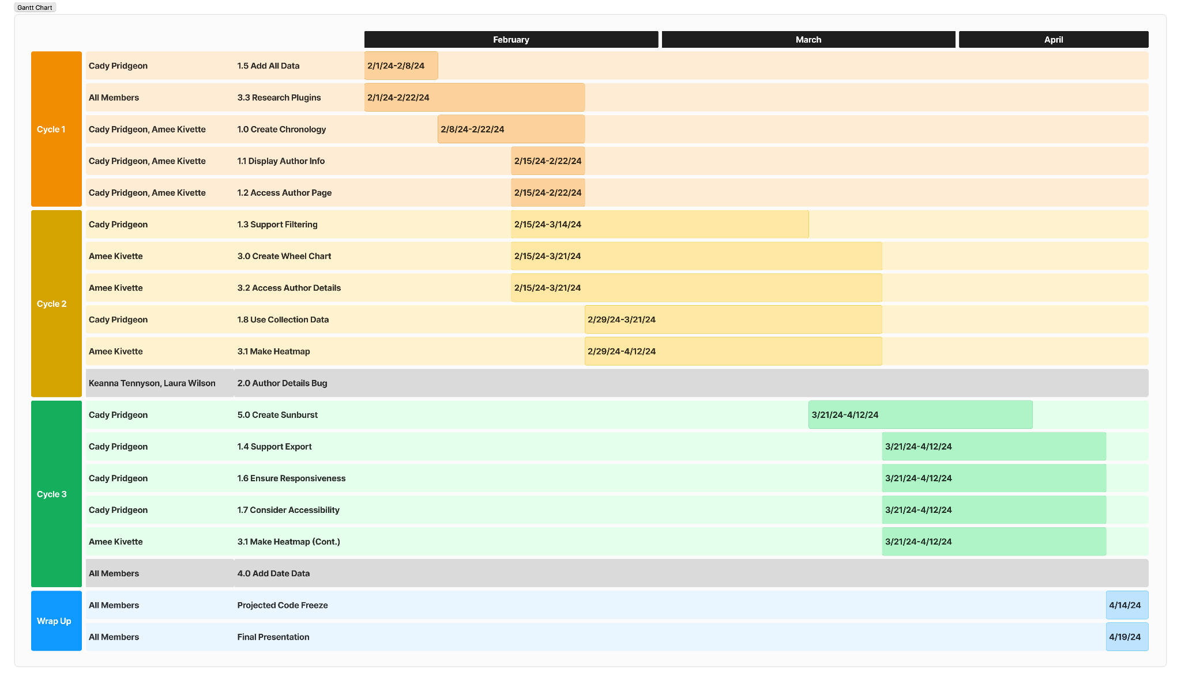

**Figure 12. Gantt Chart with Estimated Development Schedule and Projected Code Freeze**

# Risk Mitigation • Cady Pridgeon

During the Architectural Spike, the project sponsors identified risks associated with a common approach to data visualization in similar projects. In previous semesters, students hosted their visualizations on the website by creating their projects on GitHub and utilizing iframes to display their work. However, the project web developer advised that this approach leads to security and permissions issues down the road [1]. Thus, the team focused Cycle 1 on creating an MVP visualization with Omeka Classic plugins. This ensured that the group had visualizations to pursue within the approved CMS [2].

On the other hand, many of the plugins offered within Omeka Classic were not very flexible or customizable. To ensure there was a backup visualization, the team decided to pursue the development of one experimental visualization using D3.js. Additionally, to better align with sponsor requests, this visualization provided a more impactful visualization, showcasing the magnitude of available data [2].

Since presenting the D3.js solution to the sponsor and project web developer, the sponsor and developer approved and encouraged the use of an external visualization with the Alabama Authors project. The team plans to maintain an open line of communication with the project sponsor and developer to continuously request feedback and confirm concrete support for this solution that could pose potential risks down the line.

# Test Documentation • Cady Pridgeon, Amee Kivette

## Testing Plan

Since this project is visualization-based, the team decided to pursue a manual testing method. Team members think of nominal cases and edge cases to test visualizations with. The team will then record test action steps, expected results, and actual results to determine the test result. After receiving the results, the team will pursue the next steps accordingly [2].

This visual approach to testing may not guarantee that the code is completely free of bugs, but it does confirm that the functionality of the visualization is up to standards. Especially within the Omeka Classic system, generating automatic, code-based tests is not practical for this project [2].

For further verification, the team aims to present each test to the sponsors to gain additional feedback and receive approval [2].

## Acceptance Tests

**Table 17. D3.js Chronology Basic Functionality Test**

| **D3.js Chronology - Basic Functionality** | | | | |
| --- | --- | --- | --- | --- |
| User Story | | 1.0, 1.1 Chronology Data Visualization | | |
| Test Description | | Testing for basic information and functionality on the D3.js chronology visualization. | | |
| Programs/Files | | GitHub, index.html, authors.csv | | |
| Step | Action | Expected Result | Actual Result | Status |
| 1 | Scroll down on trackpad. | Visualization zooms in. | Visualization zooms in based on cursor location. | Pass |
| 2 | Hover over a bar. | Author information shows on a tooltip. | Author name, lifespan, years lived, and county (if available) show on the tooltip. | Pass |
| 3 | Bar visualization correlates to the correct author and lifespan. | Bar length correctly lines up with birth year and death year. | The bar length does line up with the year axis. | Pass |

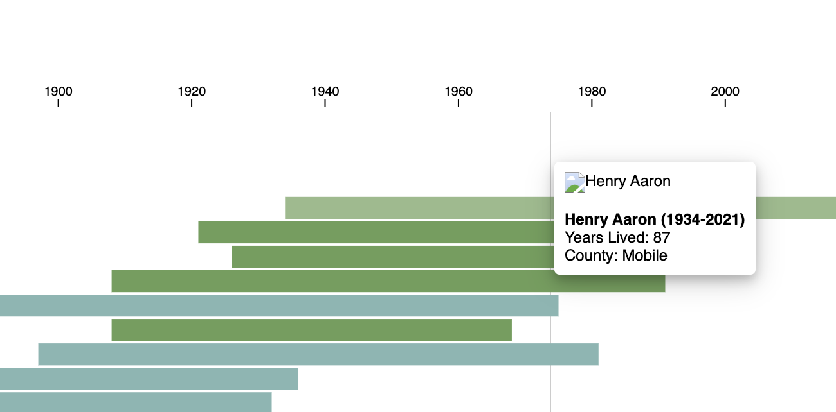 **Figure 13. D3.js Chronology Basic Functionality Test Results**

**Table 18. D3.js Chronology Complex Functionality Test**

| **D3.js Chronology - Complex Functionality** | | | | |
| --- | --- | --- | --- | --- |
| User Story | | 1.0, 1.1, 1.2 Chronology Data Visualization | | |
| Test Description | | Testing for advanced interaction states and added information on the D3.js chronology visualization. | | |
| Programs/Files | | GitHub, index.html, authors.csv, images | | |
| Step | Action | Expected Result | Actual Result | Status |
| 1 | Scroll down on trackpad. | Visualization zooms in. | Visualization zooms in based on cursor location. | Pass |
| 2 | Hover over a bar. | Author information shows on a tooltip, including author image. | Bar lightens and author information shows on the tooltip, including the author image when available. Additionally, there is a guiding vertical line to assist with axes alignment. | Pass |
| 3 | Click on a bar. | Alabama Authors details page opens. | When the page link is available, the correct page opens in a new tab. | Pass |

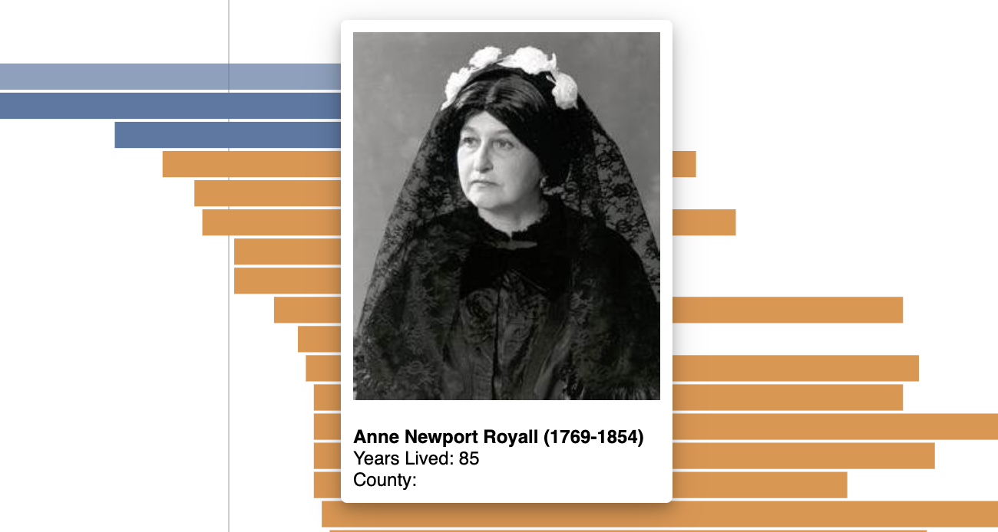

**Figure 14. D3.js Chronology Complex Functionality Test Results**

**Table 19. Neatline - Functionality of Waypoints Widget**

| **Neatline - Functionality of Waypoints Widget** | | | | |
| --- | --- | --- | --- | --- |
| User Story | | 3.0, 3.1, 3.2 Publication Calendar Wheel Data Visualization | | |
| Test Description | | Testing for basic information and functionality on the Neatline publication visualization with Waypoints widgets activated. | | |
| Programs/Files | | publication.data.excel, publication.data.HTML.format.pdf,  chronology.heat.map.svg, chronology_heat_map2.png, publication_totals_and_gradient_colors.pdf | | |
| Step | Action | Expected Result | Actual Result | Status |
| 1 | Scroll up and down using the mouse. | The background image will zoom in and out. | The background image zooms in and out. | Pass |
| 2 | Hover over defined areas on the background image. | Associated time period will display in a popover. | Associated time period displays in a popover and is highlighted in the navigation pane. | Pass |
| 3 | Click the defined area on the background image. | A list of publications will appear in a popover. | A list of publications appears in a popover. | Pass |
| 4 | Click on item in the navigation pane. | A list of publications will appear in a popover. | A list of publications appears in a popover. | Pass |
| 5 | Click on icon depicting the publication cover. | The browser will navigate to the publication image. | The browser navigates to the publication image. | Pass |
| 6 | Click on publication title. | The browser will navigate to the publication details page within the collection. | The browser navigates to the publication details page within the collection. | Pass |

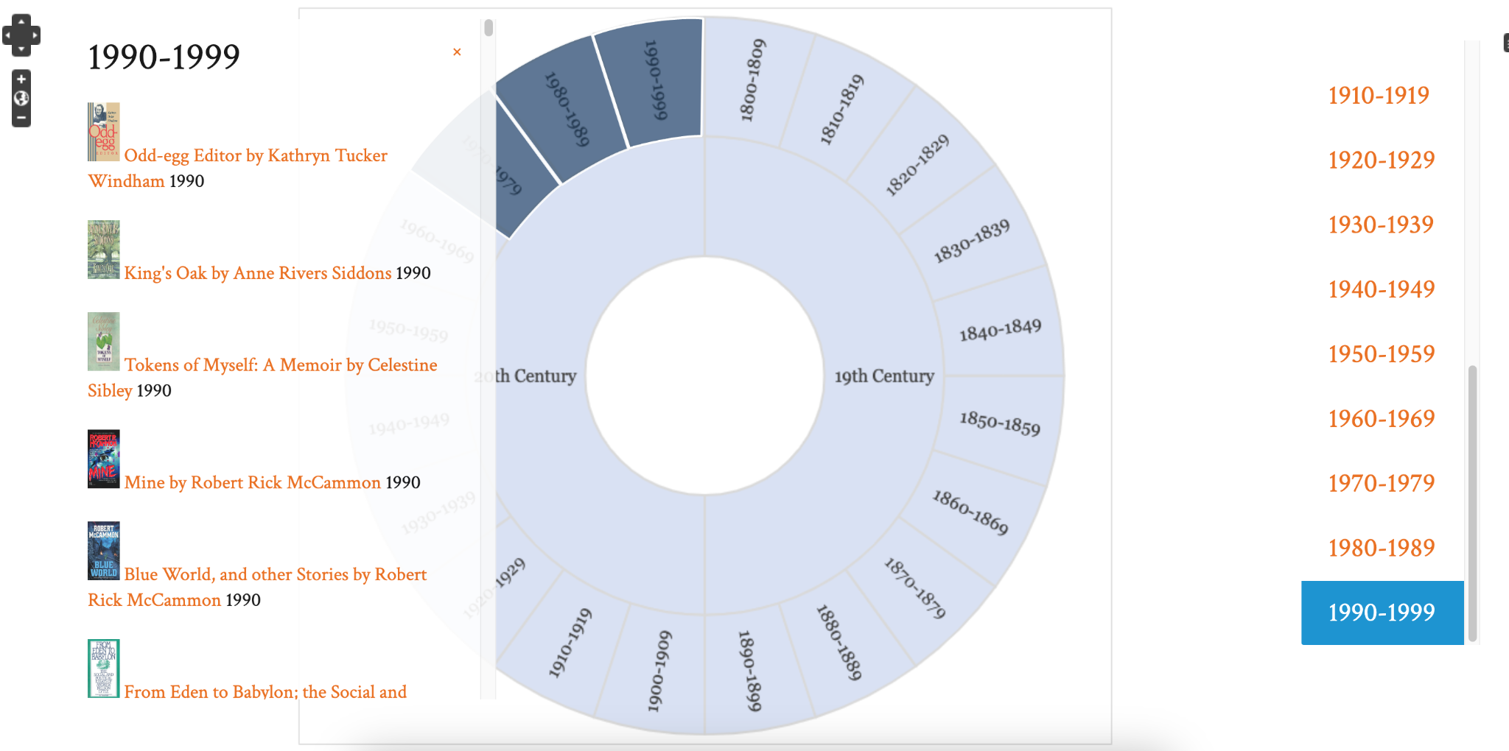

**Figure 15. Functionality of Waypoints Widget Test Results**

**Table 20. D3.js Chronology Advanced Functionality Test**

| **D3.js Chronology - Advanced Functionality** | | | | |
| --- | --- | --- | --- | --- |
| User Story | | 1.1, 1.2, 1.3, 1.8 Chronology Data Visualization | | |
| Test Description | | Testing for advanced interaction functionality with the AL Author collection and total author data on the D3.js chronology visualization. | | |
| Programs/Files | | GitHub, index.html, authors.csv, export.csv, images | | |
| Step | Action | Expected Result | Actual Result | Status |
| 1 | Scroll down on trackpad. | Visualization zooms in. | Visualization zooms in based on cursor location. | Pass |
| 2 | Hover over a bar. | Author information shows on a tooltip, including author image. | Bar lightens and author information shows on the tooltip, including the author image when available. Additionally, there is a guiding vertical line to assist with axes alignment. | Pass |
| 3 | Click on a bar. | Alabama Authors details page opens. | When the page link is available, the correct page opens in a new tab. | Pass |
| 4 | Select a sort option. | The chronology updates with the correct sort option. | The chronology correctly sorts and updates based on the selected sorting option. | Pass |
| 5 | Select a filter option. | The chronology updates with the correct filter option. | The chronology correctly filters and updates based on the selected filtering option. | Pass |
| 6 | Change view option. | The chronology updates with the new view option. | The chronology updates with the correct view data and displays the corresponding number of data entries. | Pass |
| 7 | Hover over a bar. | Author information shows on a tooltip, including author image if available. | Bar lightens and author information shows on the tooltip, including the author image when available. Additionally, there is a guiding vertical line to assist with axes alignment. | Pass |
| 8 | Select a sort option. | The chronology updates with the correct sort option. | The chronology correctly sorts and updates based on the selected sorting option. | Pass |
| 9 | Select a filter option. | The chronology updates with the correct filter option. | The chronology correctly filters and updates based on the selected filtering option. | Pass |

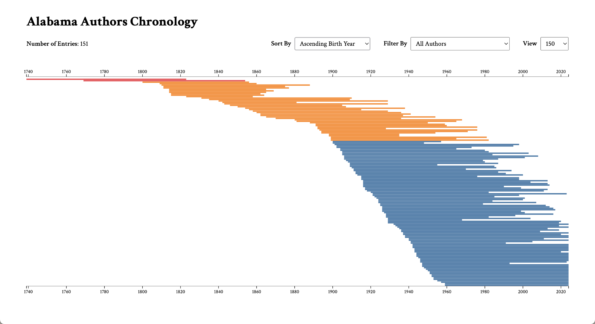

**Figure 16. D3.js Chronology Advanced Functionality Test Results (Sort)**

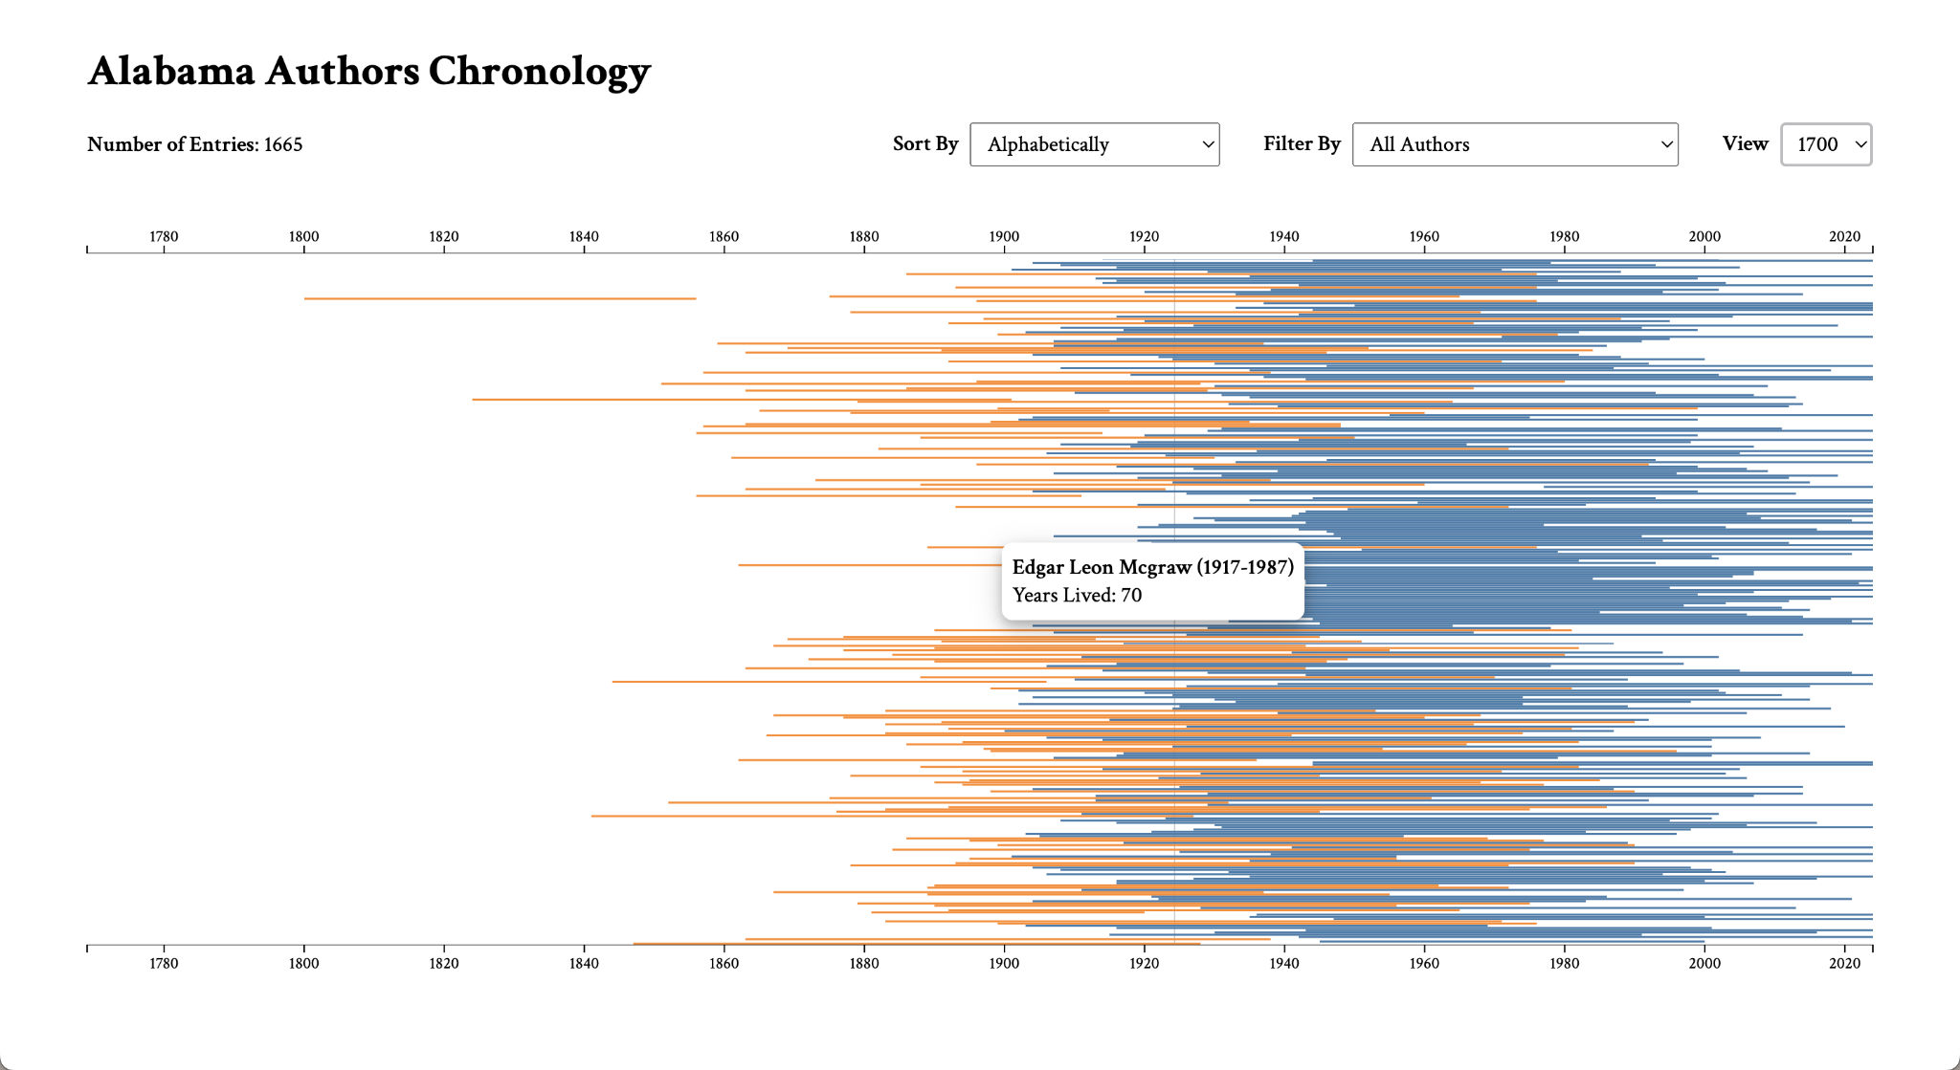

**Figure 17. D3.js Chronology Advanced Functionality Test Results (Hover on 1700 View**

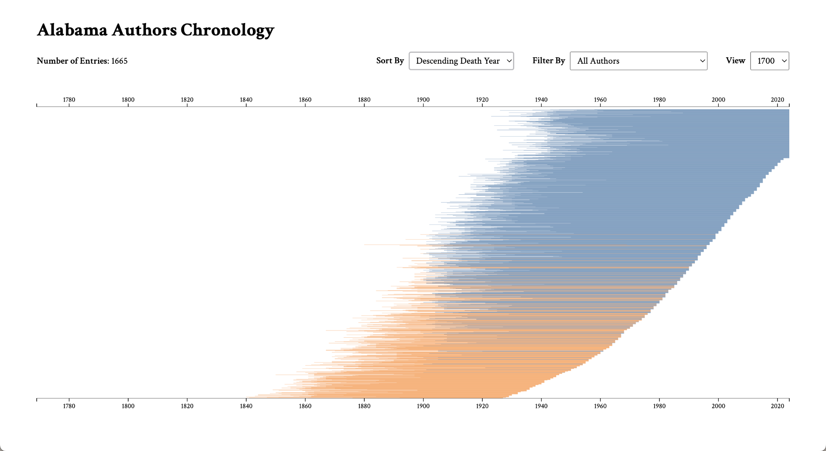

**Figure 18. D3.js Chronology Advanced Functionality Test Results (Sort)**

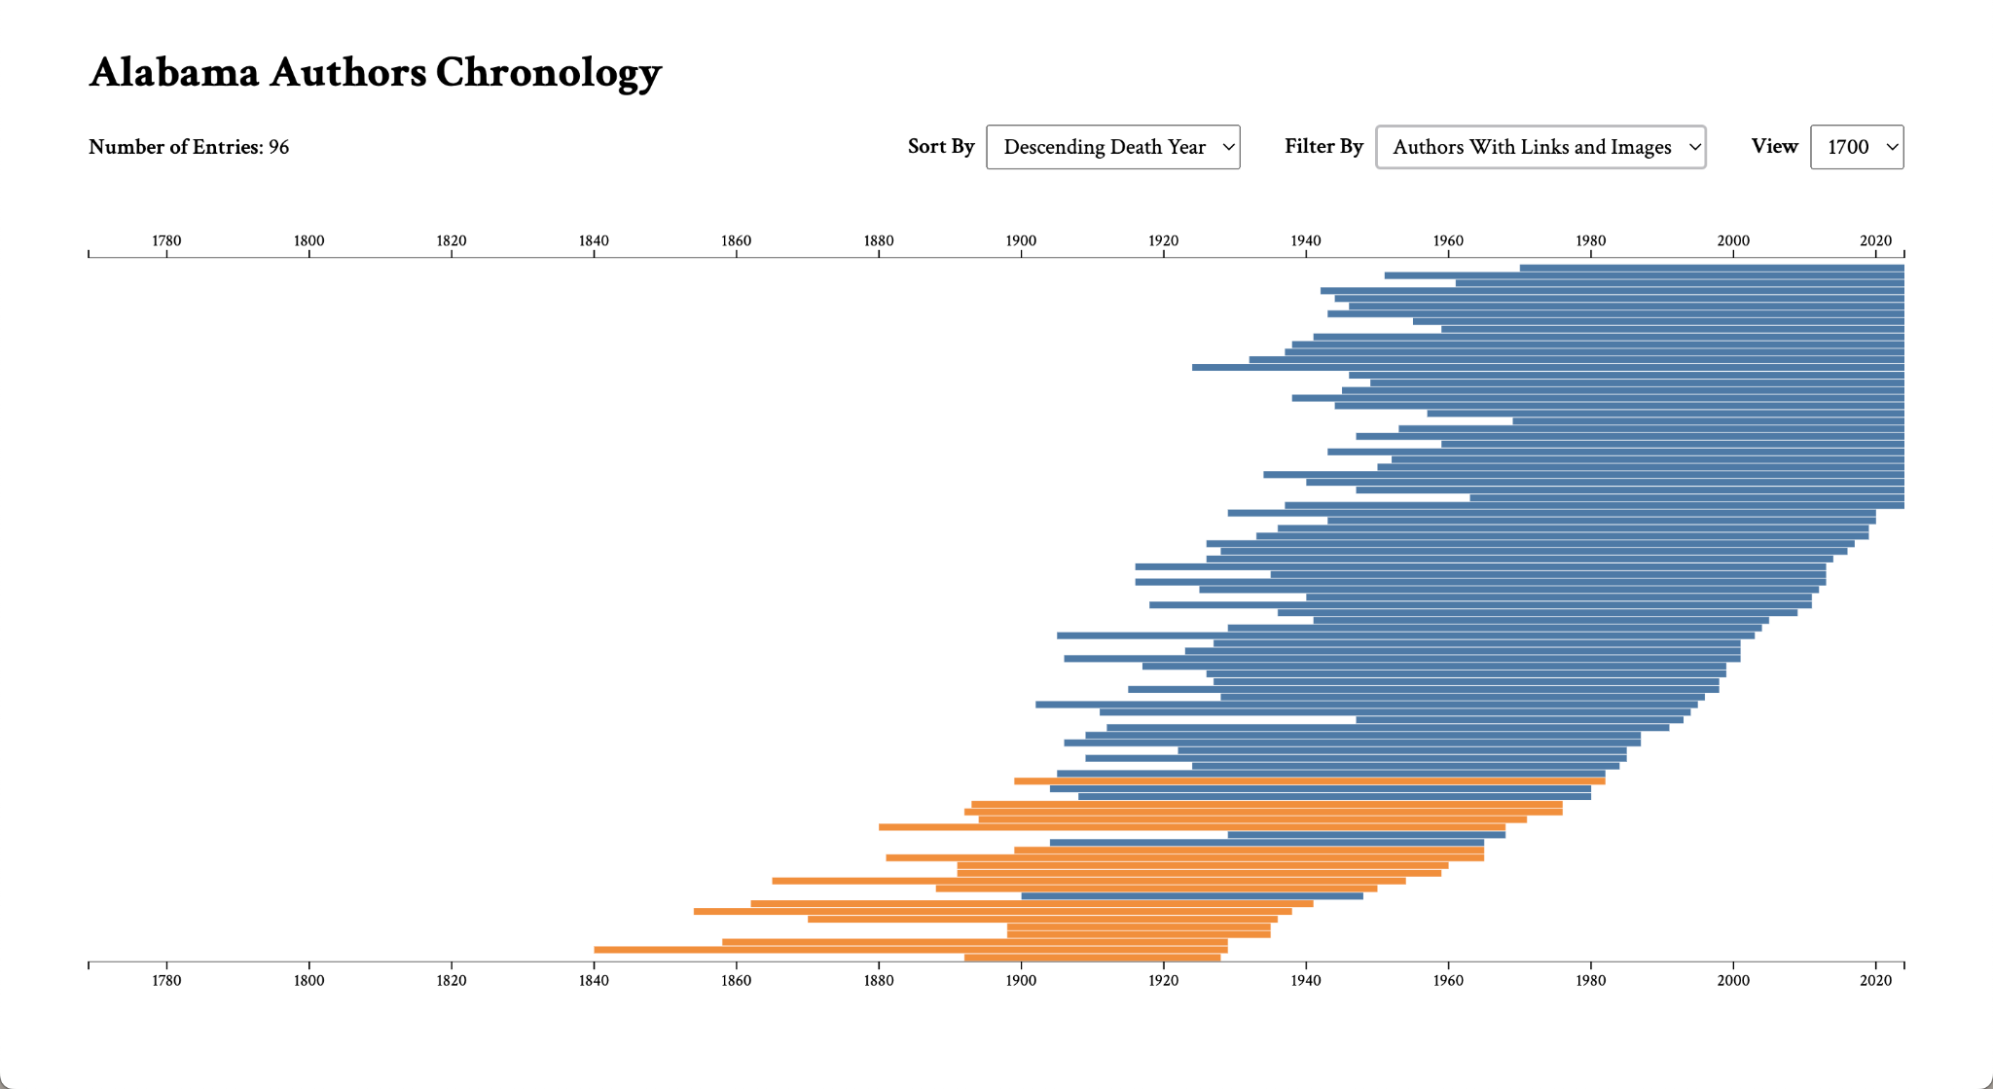

**Figure 19. D3.js Chronology Advanced Functionality Test Results (Filter)**

## Unit Tests

**Table 21. D3.js Chronology Zoom Unit Test**

| **D3.js Chronology - Zoom** | | | | |
| --- | --- | --- | --- | --- |
| User Story | | 1.0 Chronology Data Visualization | | |
| Test Description | | Testing for zoom functionality on D3.js chronology visualization. | | |
| Programs/Files | | GitHub, index.html, authors.csv, export.csv | | |
| Step | Action | Expected Result | Actual Result | Status |
| 1 | Scroll down on the trackpad. | Zoom into bars. | Zoom into bars that the cursor is nearest to. | Pass |
| 2 | Click and drag up. | Move up to view the bars above. | Moves up on visualization. | Pass |
| 3 | Click and drag down. | Move down to view the bars below. | Moves down on visualization. | Pass |
| 4 | Scroll up on the trackpad. | Zoom out to view all bars. | Zooms out using the cursor as the point of reference. | Pass |

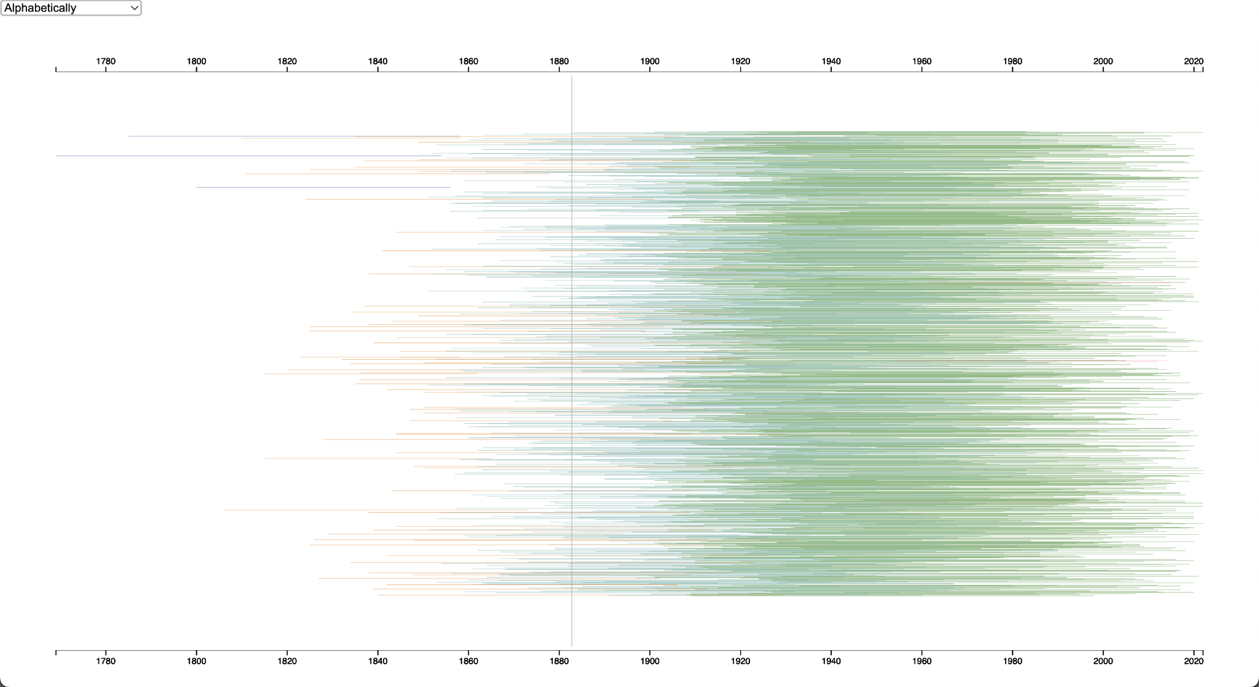

**Figure 20. D3.js Chronology Zoom Test Results (Zoom Out)**

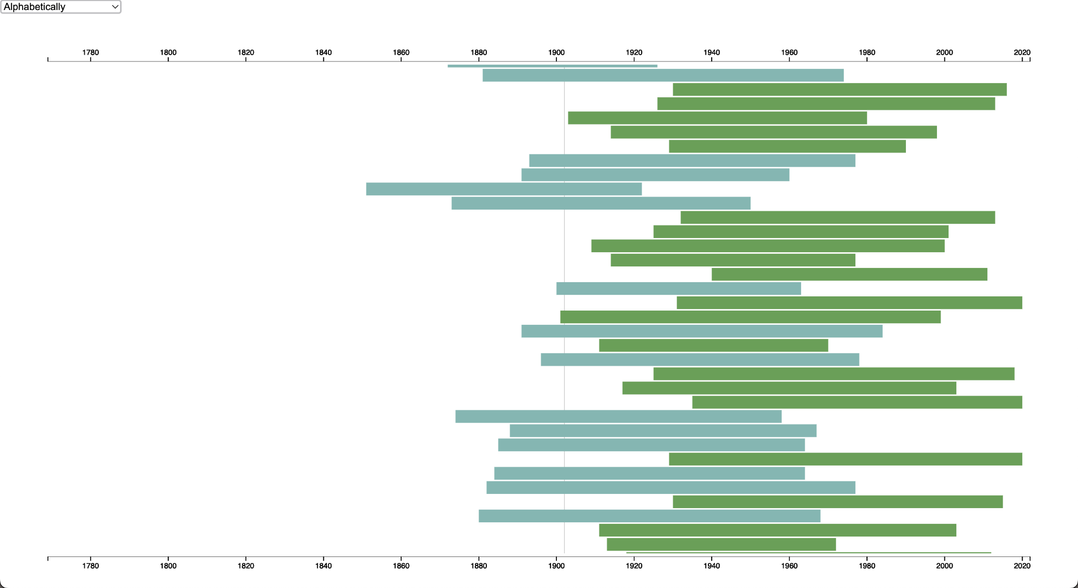

**Figure 21. D3.js Chronology Zoom Test Results (Zoom In)**

**Table 22. D3.js Chronology Sort Unit Test**

| **D3.js Chronology - Sort** | | | | |
| --- | --- | --- | --- | --- |
| User Story | | 1.3 Chronology Data Visualization | | |
| Test Description | | Testing for sort functionality on D3.js chronology visualization. | | |
| Programs/Files | | GitHub, index.html, authors.csv, export.csv | | |
| Step | Action | Expected Result | Actual Result | Status |
| 1 | Select “Alphabetically” from the dropdown. | Bars are sorted in alphabetical order. | Bars start with two out-of-place entries and then continue in alphabetical order. | Pass |
| 2 | Select “Ascending Birth Year” from the dropdown. | Bars are sorted in ascending birth year order. | Bars are correctly sorted by ascending birth year. | Pass |
| 3 | Select “Descending Birth Year” from the dropdown. | Bars are sorted in ascending birth year order. | Bars are correctly sorted by descending birth year. | Pass |
| 4 | Select “Ascending Death Year” from the dropdown. | Bars are sorted in ascending death year order. | Bars are correctly sorted by ascending death year. | Pass |
| 5 | Select “Descending Death Year” from the dropdown. | Bars are sorted in descending death year order. | Bars are correctly sorted by descending death year. | Pass |
| 6 | Select “Ascending Lifespan” from the dropdown. | Bars are sorted in ascending lifespan order. | Bars begin with lifespans of 100+ and then continue in ascending order. | Pass |
| 7 | Select “Descending Lifespan” from the dropdown. | Bars are sorted in ascending lifespan order. | Bars begin descending from lifespans of 99 but end with lifespans of 100+. | Pass |

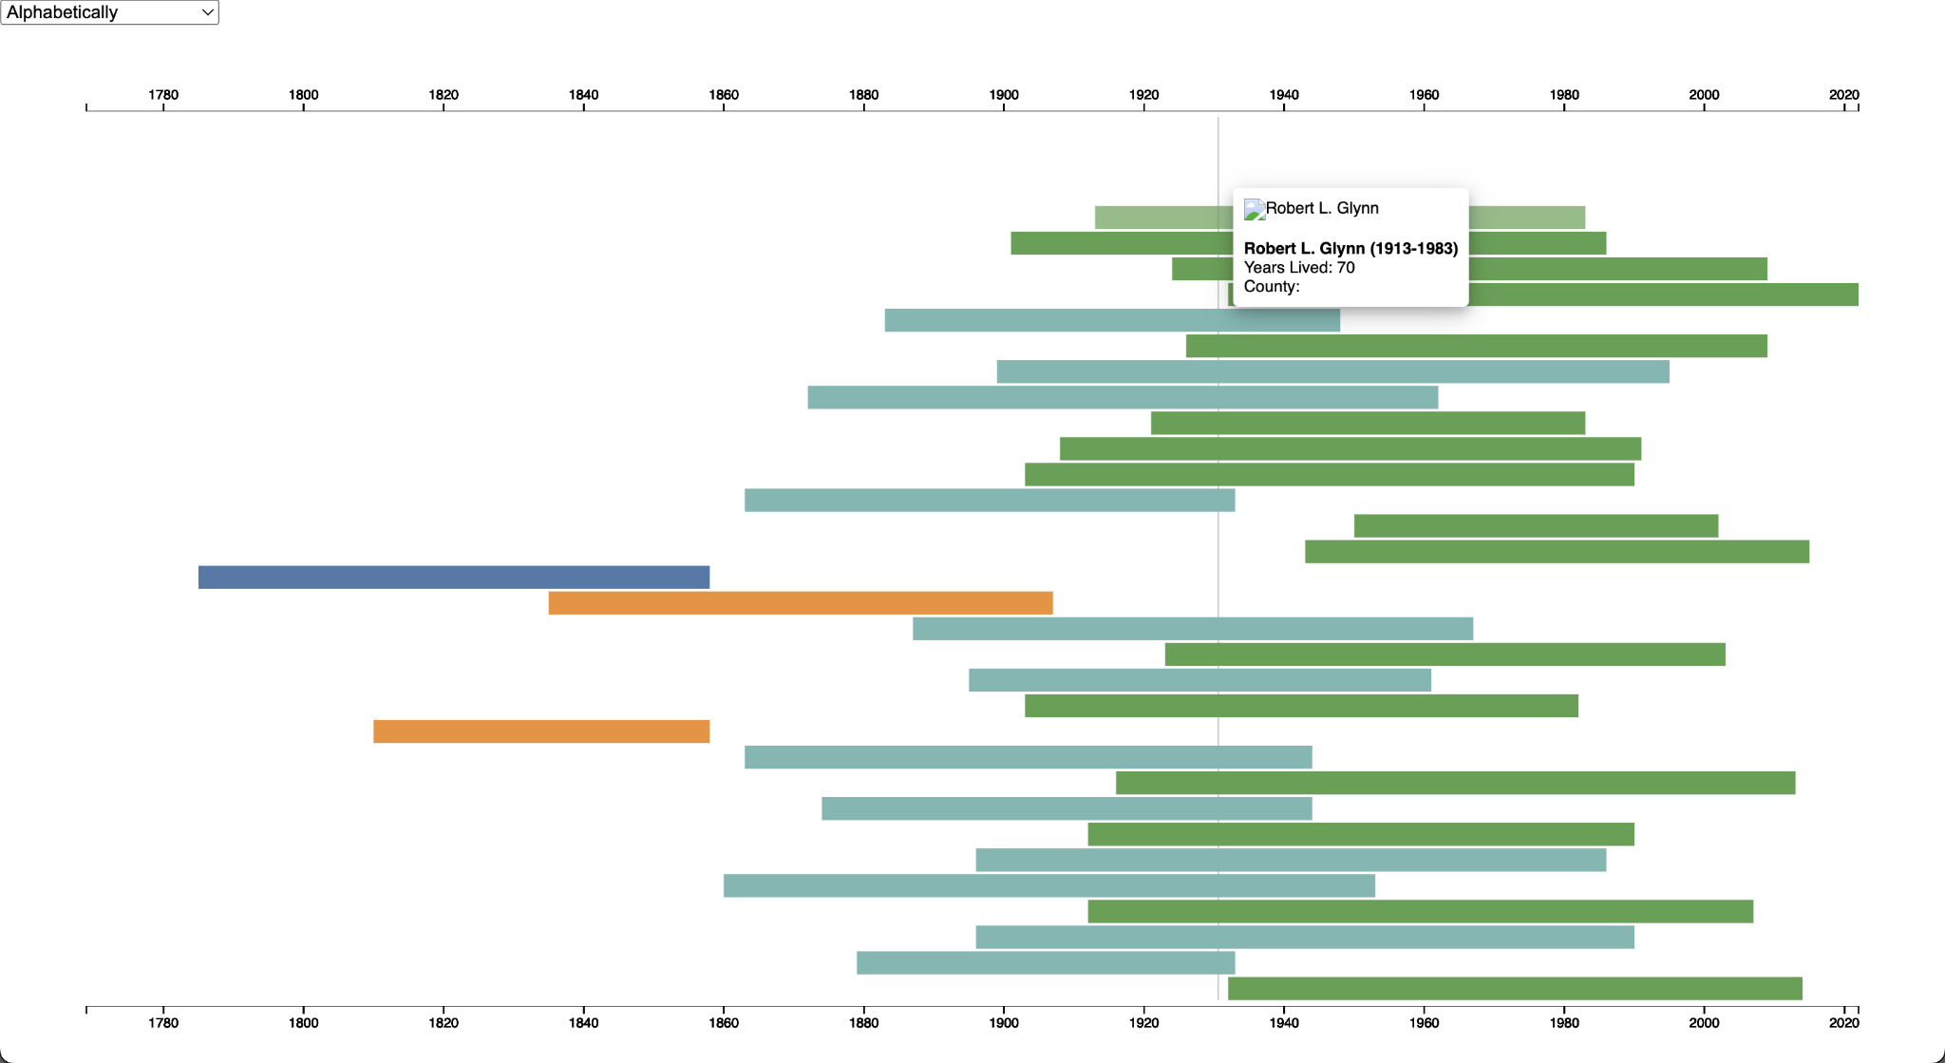

**Figure 22. D3.js Chronology Sort Test Initial Results (Alphabetically)**

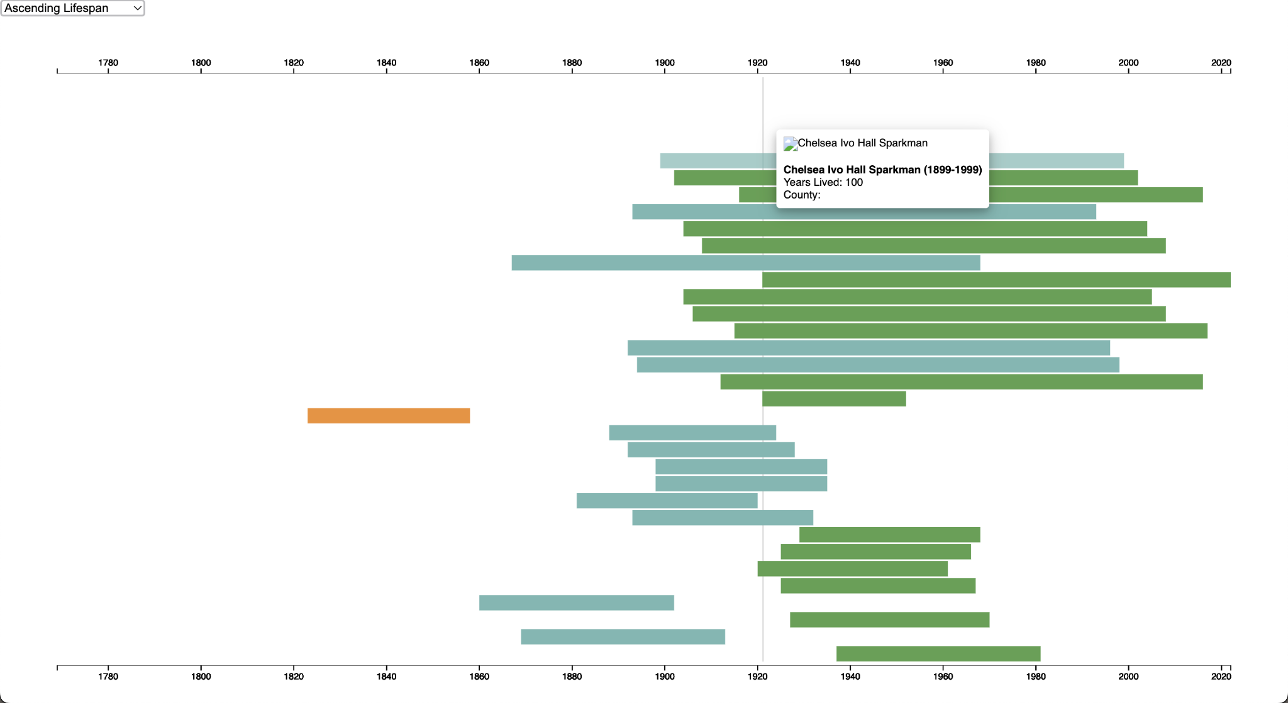

**Figure 23. D3.js Chronology Sort Test Initial Results (Ascending Lifespan)**

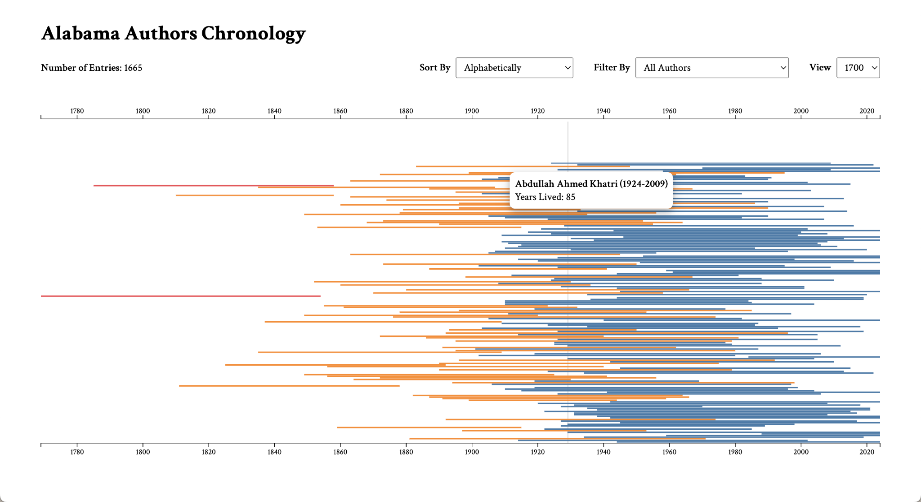

**Figure 24. D3.js Chronology Sort Test Current Results (Alphabetically)**

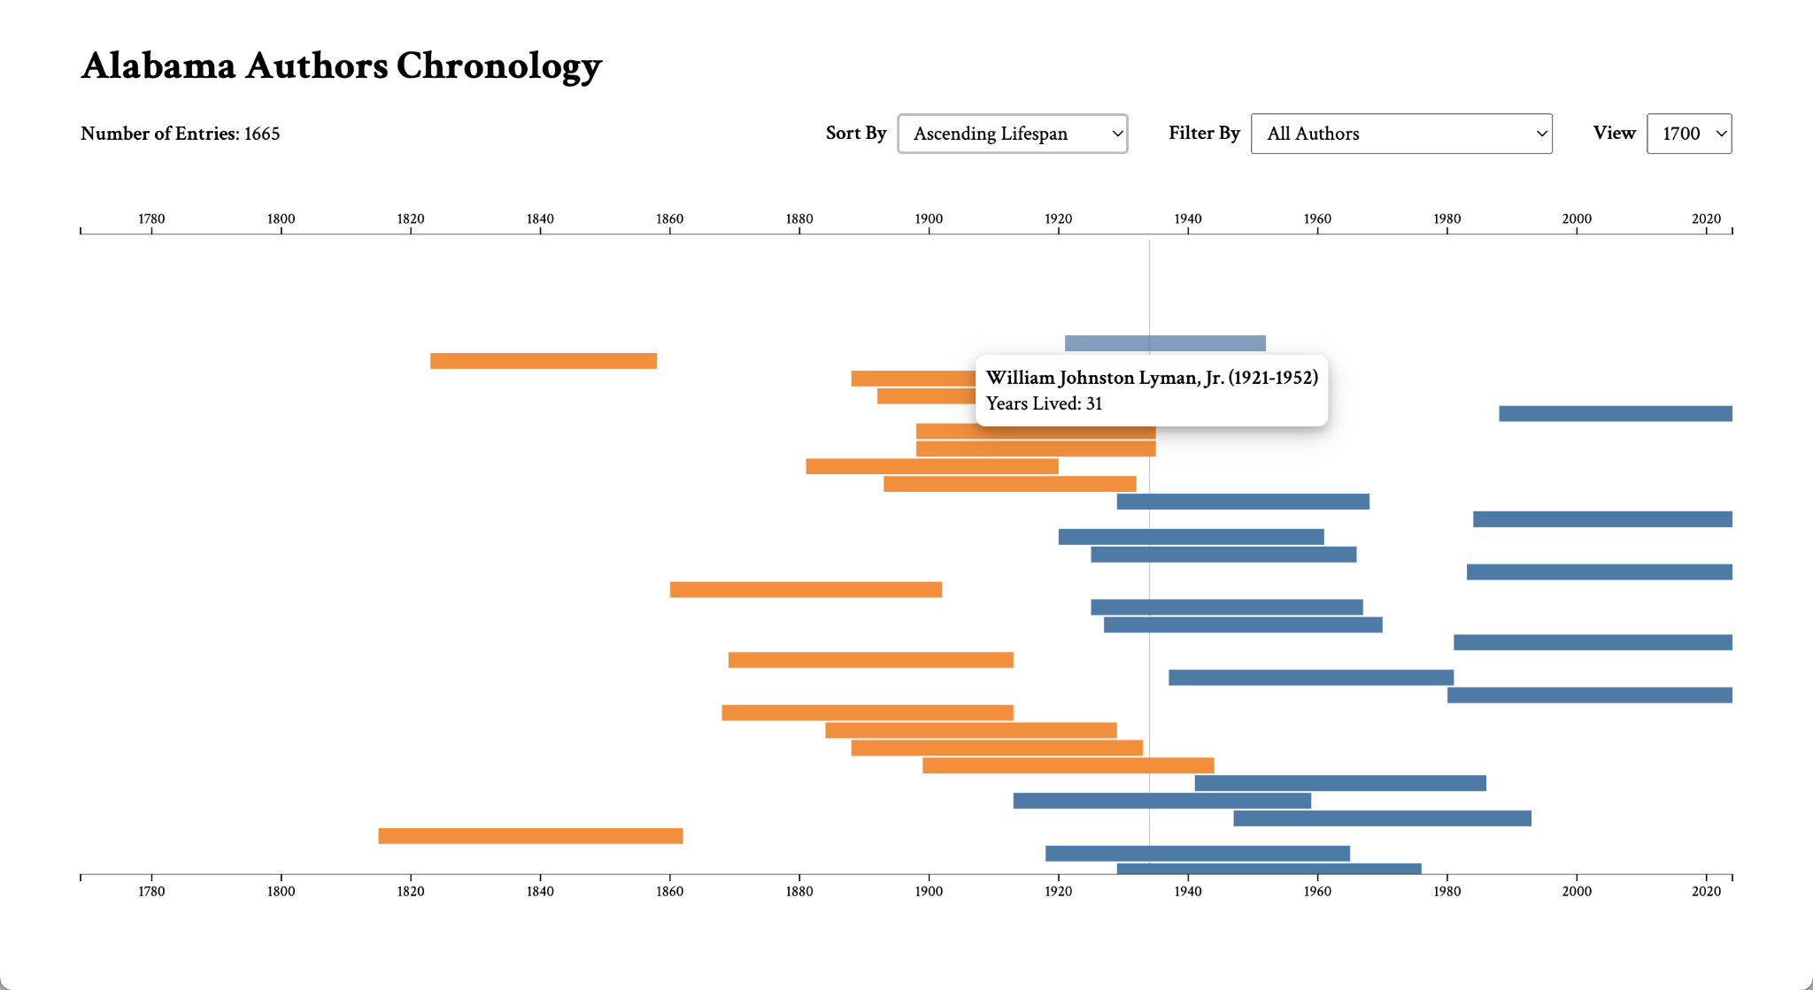

**Figure 25. D3.js Chronology Sort Test Current Results (Ascending Lifespan)**

**Table 23. D3.js Chronology Filter Unit Test**

| **D3.js Chronology - Filter** | | | | |
| --- | --- | --- | --- | --- |
| User Story | | 1.3 Chronology Data Visualization | | |
| Test Description | | Testing for filter functionality on D3.js chronology visualization. | | |
| Programs/Files | | GitHub, index.html, authors.csv, export.csv | | |
| Step | Action | Expected Result | Actual Result | Status |
| 1 | Select “All Authors” from the dropdown. | All bars are shown. | All author bars are visible. | Pass |
| 2 | Select “Authors With Links” from the dropdown. | Only bars that contain author links are shown. | Author bars with links are visible. | Pass |
| 3 | Select “Authors With Images” from the dropdown. | Only bars that contain author images are shown. | Author bars with images are visible. | Pass |
| 4 | Select “Authors With Links and Images” from the dropdown. | Only bars that contain author images and links are shown. | Author bars with links and images are visible. | Pass |

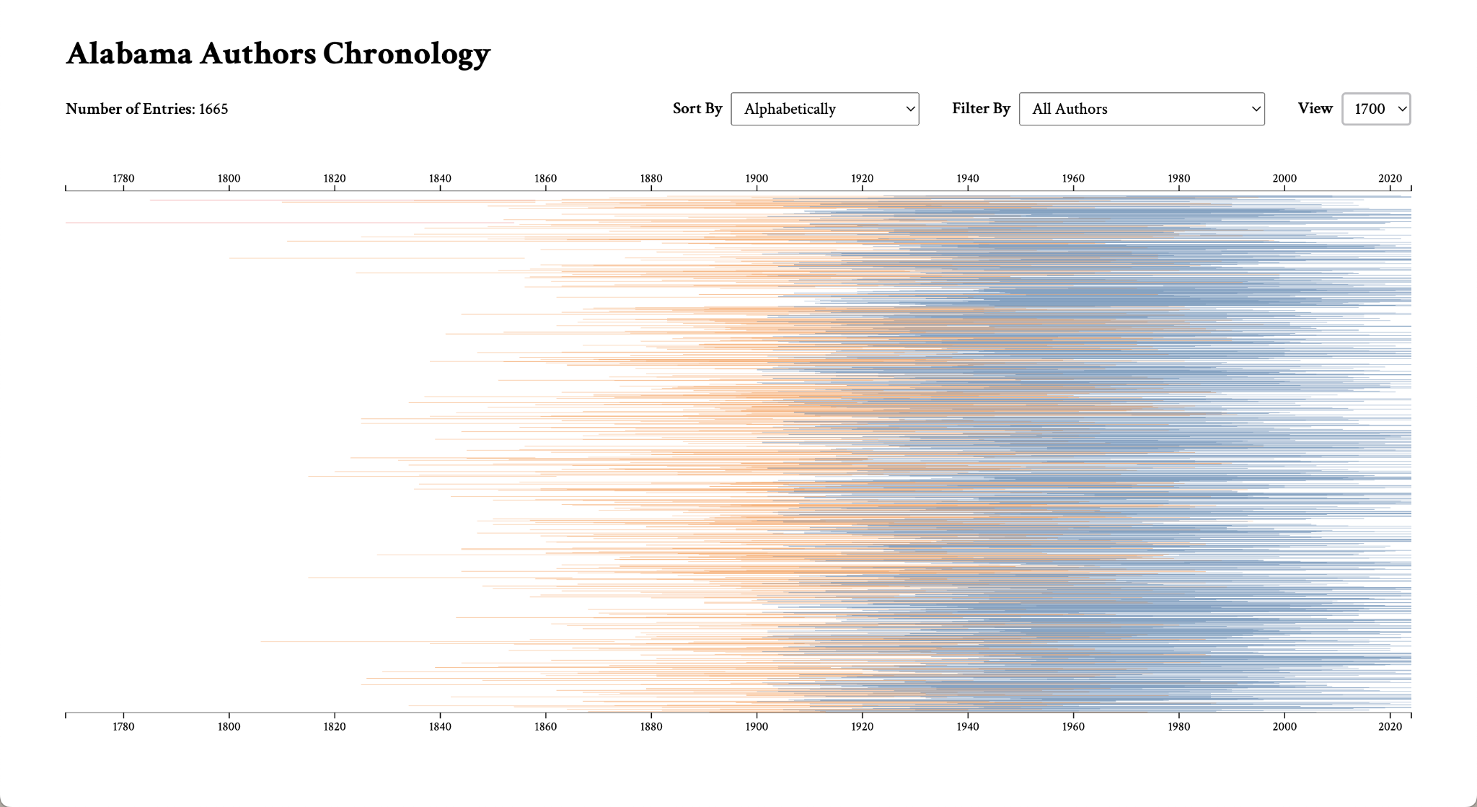

**Figure 26. D3.js Chronology Filter Test Results (All Authors)**

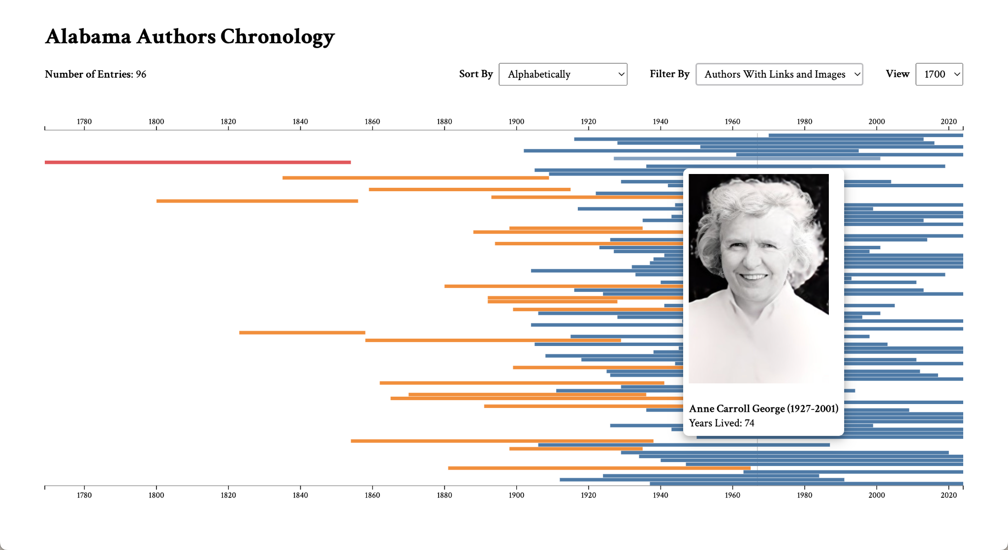

**Figure 27. D3.js Chronology Filter Test Results (Authors With Links and Images)**

**Table 24. D3.js Chronology View Unit Test**

| **D3.js Chronology - View** | | | | |
| --- | --- | --- | --- | --- |
| User Story | | 1.3 Chronology Data Visualization | | |
| Test Description | | Testing for filter functionality on D3.js chronology visualization. | | |
| Programs/Files | | GitHub, index.html, authors.csv, export.csv | | |
| Step | Action | Expected Result | Actual Result | Status |
| 1 | Select “150” from the dropdown. | Bars from the AL Author collection populate (around 150). | Bars from the AL Author collection are shown (151 total). | Pass |
| 2 | Select “1700” from the dropdown. | Bars from the entire author dataset populate (around 1700). | Bars from the author dataset are shown (1665 total). | Pass |

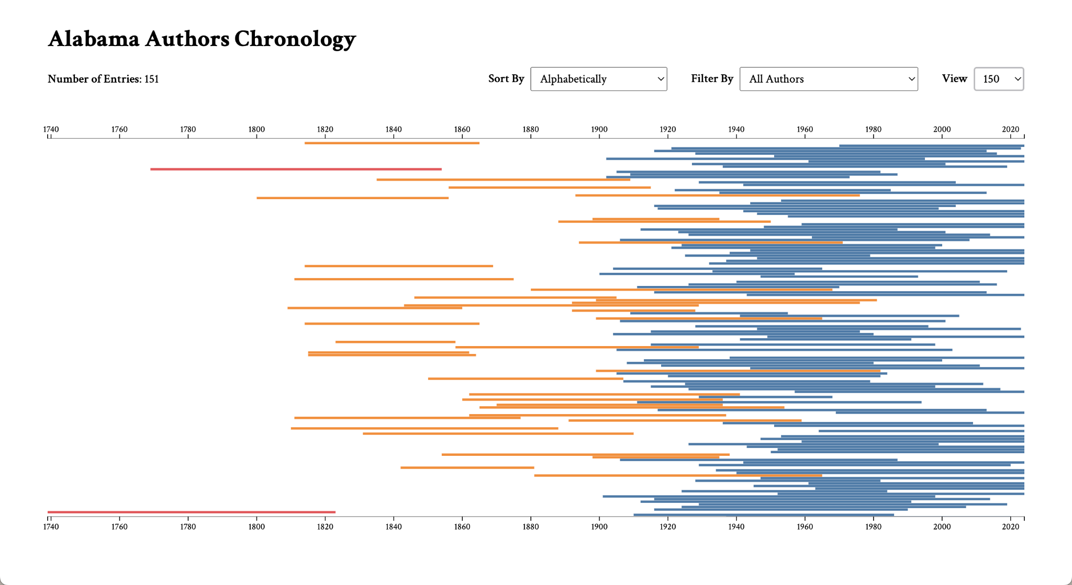

**Figure 28. D3.js Chronology View Test Results (150)**



**Figure 29. D3.js Chronology Filter View Results (1700)**

**Table 25. D3.js Chronology Tooltip Unit Test**

| **D3.js Chronology - Tooltip** | | | | |
| --- | --- | --- | --- | --- |
| User Story | | 1.6 Chronology Data Visualization | | |
| Test Description | | Testing for dynamic tooltip placement depending on cursor location. | | |
| Programs/Files | | GitHub, index.html, authors.csv, export.csv, images | | |
| Step | Action | Expected Result | Actual Result | Status |
| 1 | Hover on a bar on the top half of the chronology. | The tooltip populates below the cursor. | The tooltip shows below the cursor. | Pass |
| 2 | Hover on a bar on the bottom half of the chronology. | The tooltip populates above the cursor. | The tooltip shows above the cursor. | Pass |

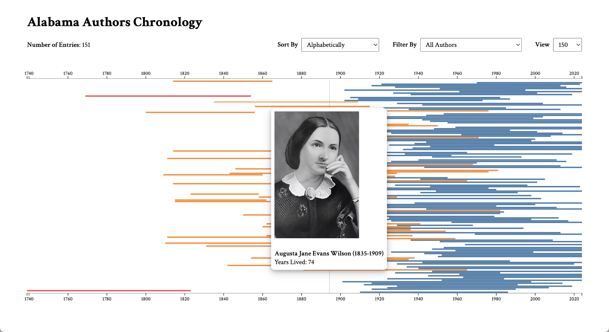

**Figure 30. D3.js Chronology Tooltip Test Results (Top Half)**

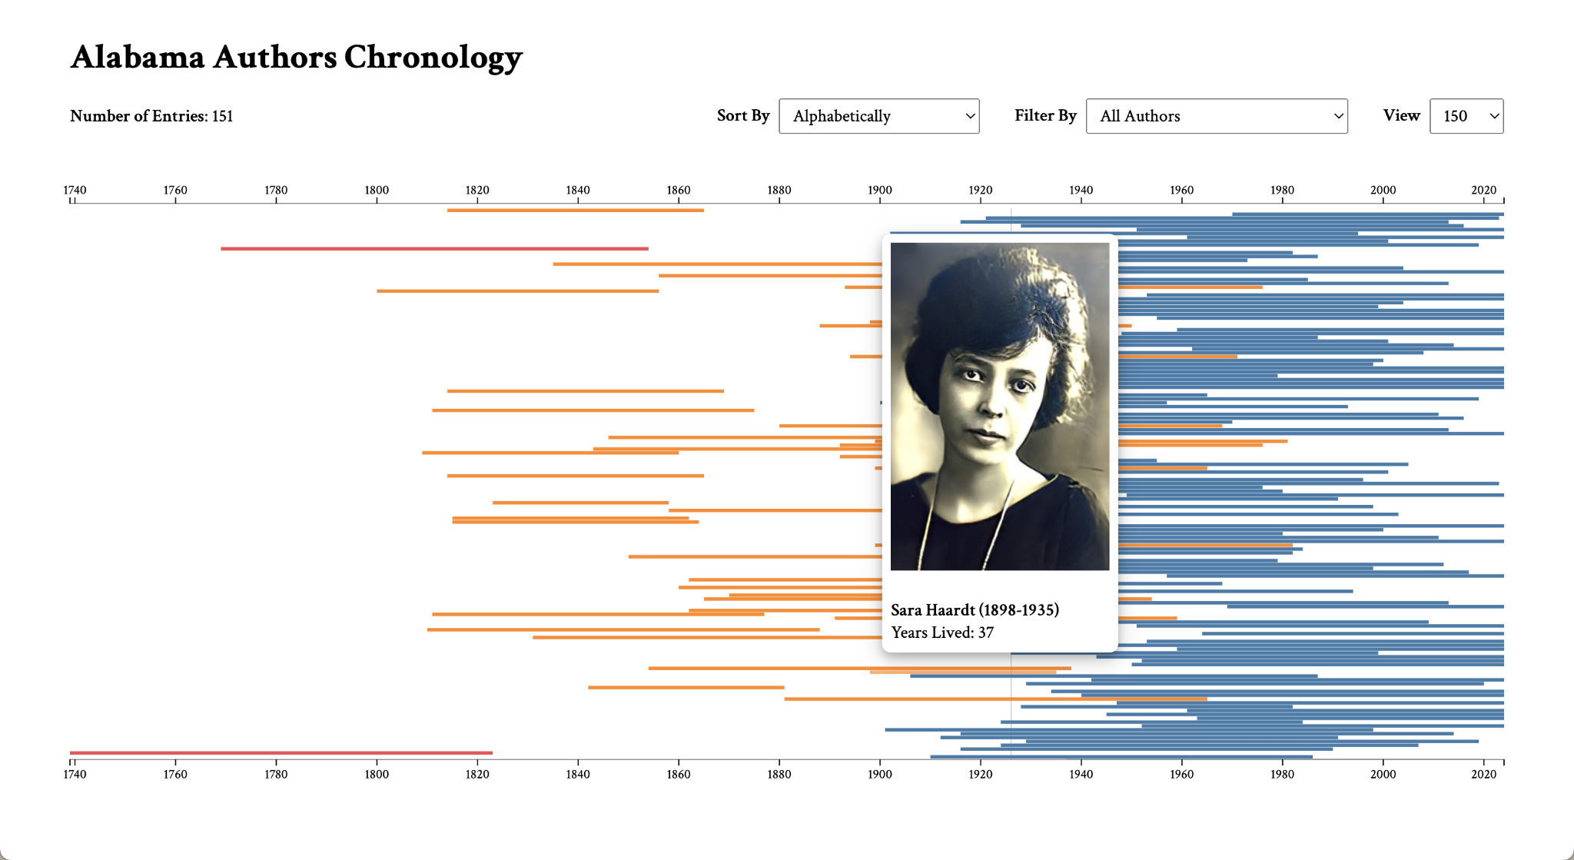

**Figure 31. D3.js Chronology Tooltip Test Results (Bottom Half)**

**Table 26. D3.js Chronology Color-Blindness Unit Test**

| **D3.js Chronology - Color-Blindness** | | | | |
| --- | --- | --- | --- | --- |
| User Story | | 1.7 Chronology Data Visualization | | |
| Test Description | | Testing for color-blindness accessibility on the chronology. | | |
| Programs/Files | | GitHub, index.html, authors.csv, export.csv, images, Colorblindly extension on Google Chrome | | |
| Step | Action | Expected Result | Actual Result | Status |
| 1 | View the page with the normal vision setting. | The color contrast on the chronology is visible. | The color contrast is discernable. | Pass |
| 2 | View the page with the monochromacy setting. | The color contrast on the chronology is visible. | The color contrast is discernable. | Pass |
| 3 | View the page with the green-blind setting. | The color contrast on the chronology is visible. | The color contrast is discernable. | Pass |
| 4 | View the page with the red-blind setting. | The color contrast on the chronology is visible. | The color contrast is discernable. | Pass |
| 5 | View the page with the blue-blind setting. | The color contrast on the chronology is visible. | The color contrast is discernable. | Pass |

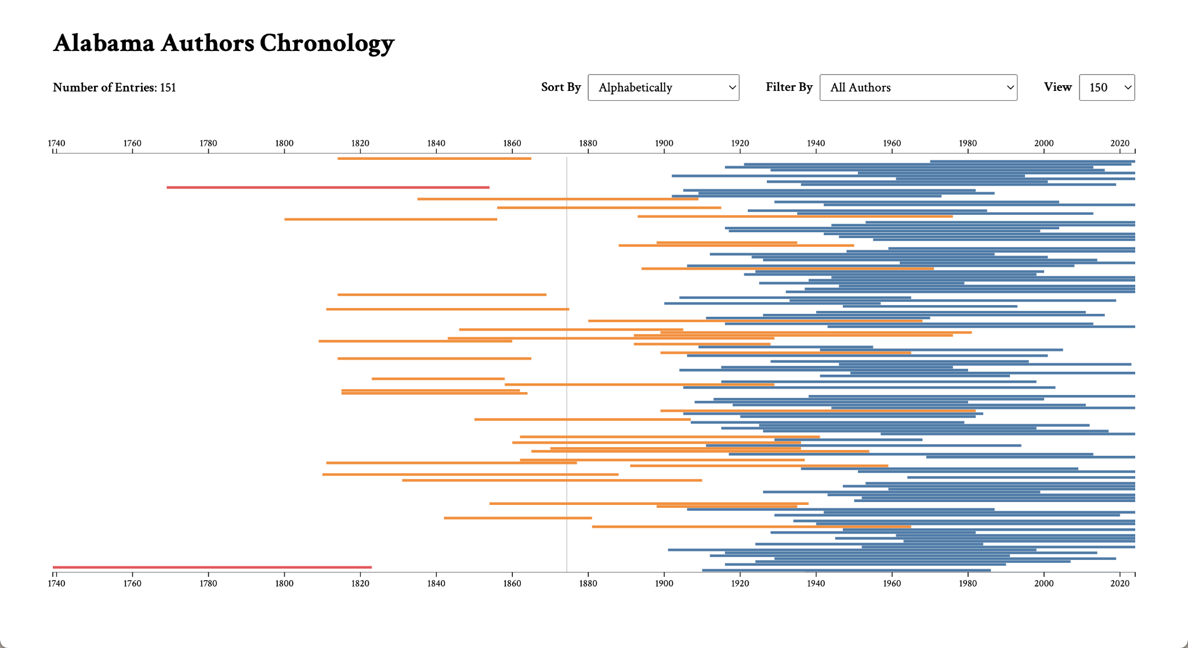

**Figure 32. D3.js Chronology Color-Blindness Test Results (Normal Vision)**

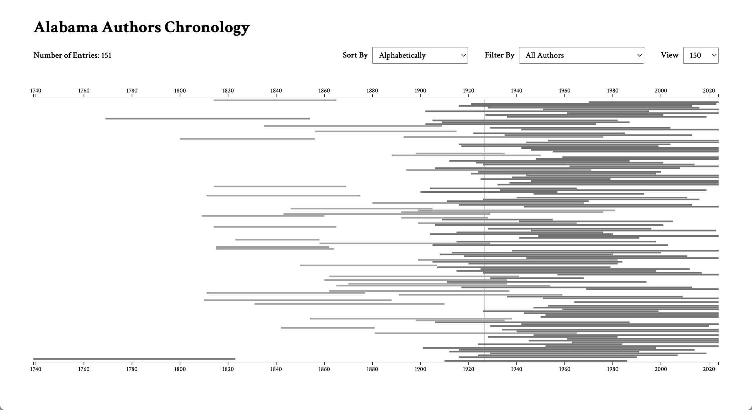

**Figure 33. D3.js Chronology Color-Blindness Test Results (Monochromacy)**

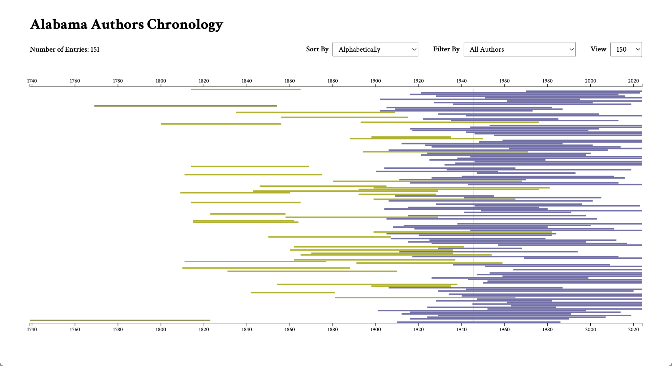

**Figure 34. D3.js Chronology Color-Blindness Test Results (Green-Blindness)**

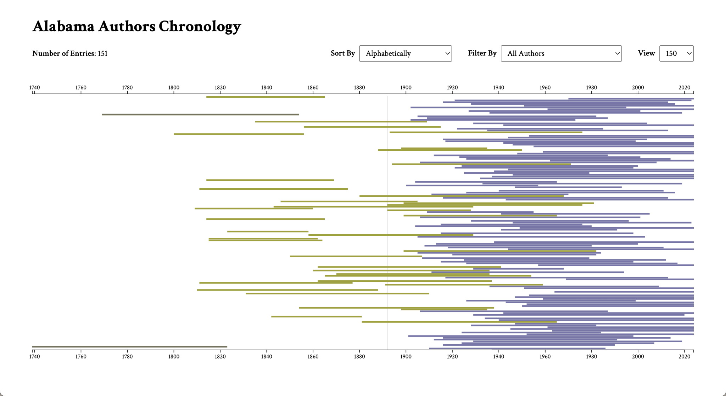

**Figure 35. D3.js Chronology Color-Blindness Test Results (Red-Blindness)**

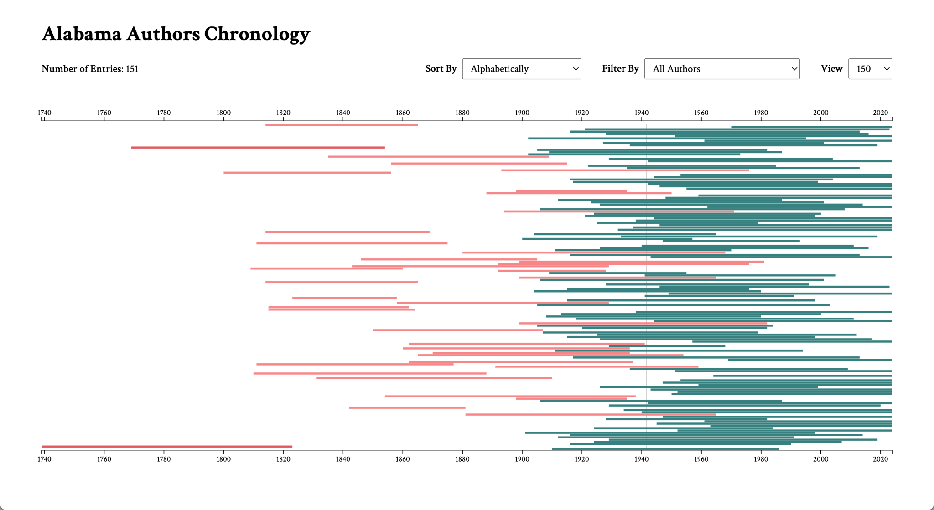

**Figure 36. D3.js Chronology Color-Blindness Test Results (Blue-Blindness)**

## Test Logs

**Table 27. Test Log for D3.js Chronology Zoom Test**

| **D3.js Chronology - Zoom** | | | | |
| --- | --- | --- | --- | --- |
| User Story | | 1.0 Chronology Data Visualization | | |
| Tester | | Cady Pridgeon | | |
| Test Date | | 02/18/2024 | | |
| Test Result | | Pass | | |
| Comments | | All actions were successful! | | |

**Table 28. Test Log for D3.js Chronology Basic Functionality Test**

| **D3.js Chronology - Basic Functionality** | | | | |
| --- | --- | --- | --- | --- |
| User Story | | 1.0 Chronology Data Visualization | | |
| Tester | | Cady Pridgeon | | |
| Test Date | | 02/18/2024 | | |
| Test Result | | Pass | | |
| Comments | | All actions were successful! | | |

**Table 29. Test Log for D3.js Chronology Complex Functionality Test**

| **D3.js Chronology - Complex Functionality** | | | | |
| --- | --- | --- | --- | --- |
| User Story | | 1.0 Chronology Data Visualization | | |
| Tester | | Cady Pridgeon | | |
| Test Date | | 02/18/2024 | | |
| Test Result | | Pass | | |
| Comments | | All actions were successful! | | |

**Table 30. Test Log for D3.js Chronology Sort Test**

| **D3.js Chronology - Sort** | | | | |
| --- | --- | --- | --- | --- |
| User Story | | 1.3 Chronology Data Visualization | | |
| Tester | | Cady Pridgeon | | |
| Test Date | | 02/18/2024 | | |
| Test Result | | Fail | | |
| Comments | | The alphabetical, ascending lifespan, and descending lifespan sorts return incorrect visualizations. These are to be addressed in the next cycle. | | |

**Table 31. Test Log for Neatline Waypoints Widget Test**

| **Neatline - Functionality of Waypoints Widget** | | | | |
| --- | --- | --- | --- | --- |
| User Story | | 3.0, 3.1, 3.2 Publication Calendar Wheel Data Visualization | | |
| Tester | | Amee Kivette | | |
| Test Date | | 3/19/2024 | | |
| Test Result | | Pass | | |
| Comments | | Default focus settings can be set for each waypoint. These all currently default to the same focus point, however this could be changed to allow for automatic zooming when clicking on waypoints. | | |

**Table 32. Test Log for D3.js Chronology Sort Test**

| **D3.js Chronology - Sort** | | | | |
| --- | --- | --- | --- | --- |
| User Story | | 1.3 Chronology Data Visualization | | |
| Tester | | Cady Pridgeon | | |
| Test Date | | 03/20/2024 | | |
| Test Result | | Pass | | |
| Comments | | The alphabetical, ascending lifespan, and descending lifespan sorts correct visualizations. The alphabetical sort failed previously because of leading whitespace. The other sorts failed primarily due to uncleaned data values. | | |

**Table 33. Test Log for D3.js Chronology Filter Test**

| **D3.js Chronology - Filter** | | | | |
| --- | --- | --- | --- | --- |
| User Story | | 1.3 Chronology Data Visualization | | |
| Tester | | Cady Pridgeon | | |
| Test Date | | 03/20/2024 | | |
| Test Result | | Pass | | |
| Comments | | All actions were successful. | | |

**Table 34. Test Log for D3.js Chronology View Test**

| **D3.js Chronology - View** | | | | |
| --- | --- | --- | --- | --- |
| User Story | | 1.3 Chronology Data Visualization | | |
| Tester | | Cady Pridgeon | | |
| Test Date | | 03/20/2024 | | |
| Test Result | | Pass | | |
| Comments | | All actions were successful. | | |

**Table 35. Test Log for D3.js Chronology Tooltip Test**

| **D3.js Chronology - Tooltip** | | | | |
| --- | --- | --- | --- | --- |
| User Story | | 1.6 Chronology Data Visualization | | |
| Tester | | Cady Pridgeon | | |
| Test Date | | 03/20/2024 | | |
| Test Result | | Pass | | |
| Comments | | All actions were successful. | | |

**Table 36. Test Log for D3.js Chronology Color-Blindness Test**

| **D3.js Chronology - Color-Blindness** | | | | |
| --- | --- | --- | --- | --- |
| User Story | | 1.7 Chronology Data Visualization | | |
| Tester | | Cady Pridgeon | | |
| Test Date | | 03/20/2024 | | |
| Test Result | | Pass | | |
| Comments | | All actions were successful. | | |

# Review Logs • Keanna Tennyson, Laura Wilson

**Table 37. Review Log for User Story 1.0**

| **Omeka Classic Chronologies** | | | | |
| --- | --- | --- | --- | --- |
| User Story | | 1.0 Chronology Data Visualization | | |
| Reviewer | | Cady Pridgeon, Laura Wilson, Keanna Tennyson, Amee Kivette | | |
| Review Date | | 02/08/2024 | | |
| Review Description | | Reviewed progress made with Omeka Classic timeline plugins. | | |
| Review Result | | Pass | | |
| Comments | | A chronology was successfully created in Neatline and Neatline Time. | | |

**Table 38. Review Log for User Story 1.1, 1.2**

| **Neatline Plugin Progress** | | | | |
| --- | --- | --- | --- | --- |
| User Story | | 1.1, 1.2 Chronology Data Visualization | | |
| Reviewer | | Cady Pridgeon, Laura Wilson, Keanna Tennyson, Amee Kivette | | |
| Review Date | | 02/15/2024 | | |
| Review Description | | Reviewed author information in Neatline visualization. | | |
| Review Result | | Pass | | |
| Comments | | Author name, description, photo, and link can be added within Neatline. | | |

**Table 39. Review Log for User Story 1.3**

| **D3.js Sort Functionality** | | | | |
| --- | --- | --- | --- | --- |
| User Story | | 1.3 Chronology Data Visualization | | |
| Reviewer | | Cady Pridgeon, Laura Wilson, Keanna Tennyson, Amee Kivette | | |
| Review Date | | 02/19/2024 | | |
| Review Description | | Reviewed sort functionality on D3.js visualization. | | |
| Review Result | | Pass/Fail | | |
| Comments | | Sort works for the most part, but some edge cases are incorrect. | | |

**Table 40. Review Log for User Story 1.8**

| **Author 150 Chronology** | | | | |
| --- | --- | --- | --- | --- |
| User Story | | 1.8 Chronology Data Visualization | | |
| Reviewer | | Cady Pridgeon, Laura Wilson, Keanna Tennyson, Amee Kivette | | |
| Review Date | | 03/14/2024 | | |
| Review Description | | Reviewed the addition of AL Author Collection data to visualization, as well as the updated view dropdown feature. | | |
| Review Result | | Pass | | |
| Comments | | The collection data was successfully integrated, and the view dropdown allowed for easy switching between the two datasets. | | |

**Table 41. Review Log for User Story 1.6, 1.7**

| **Responsiveness and Accessibility Review** | | | | |
| --- | --- | --- | --- | --- |
| User Story | | 1.6, 1.7 Chronology Data Visualization | | |
| Reviewer | | Cady Pridgeon, Laura Wilson, Keanna Tennyson, Amee Kivette | | |
| Review Date | | 03/19/2024 | | |
| Review Description | | Reviewed some responsiveness and accessibility concerns. | | |
| Review Result | | Pass | | |
| Comments | | Responsiveness is beginning to be addressed, and the color-blindness tests all pass. | | |

**Table 42. Review Log for User Story 3.0, 3.1, 3.2**

| **Neatline Heatmap Visualization** | | | | |
| --- | --- | --- | --- | --- |
| User Story | | 3.0, 3.1, 3.2 Calendar Wheel Visualization | | |
| Reviewer | | Cady Pridgeon, Laura Wilson, Keanna Tennyson, Amee Kivette | | |
| Review Date | | 03/19/2024 | | |
| Review Description | | Reviewed interactive calendar wheel accessing specific periods. A heat map with a comprehensive view of the collection through the decades. Detailed pages of each publication. | | |
| Review Result | | Pass | | |
| Comments | | Some user stories are still in progress, as well as continuous updates of the calendar wheel, heat map, and publications page. | | |

**Table 43. Review Log for User Story 1.3**

| **Revisiting D3.js Sort Functionality** | | | | |
| --- | --- | --- | --- | --- |
| User Story | | 1.3 Chronology Data Visualization | | |
| Reviewer | | Cady Pridgeon, Laura Wilson, Keanna Tennyson, Amee Kivette | | |
| Review Date | | 03/21/2024 | | |
| Review Description | | Reviewed sort functionality on D3.js visualization | | |
| Review Result | | Pass | | |
| Comments | | All sort, filter, and view options work as expected. | | |

# Lessons & Challenges • Cady Pridgeon, Amee Kivette

## Lessons

The team learned that it is valuable to rapidly prototype to generate many potential solutions when working on a project with relatively flexible requirements. It can benefit research efforts when the solution must work and show promising results as opposed to completely committing to a tool without adequate prior knowledge [2].

Dr. Rilett tasked the team with completing a usability questionnaire to provide user experience feedback for her project. This experience was eye-opening, as it guided the team to compare the Alabama Authors website to two other similar sites. This task helped the team understand where users are coming from when utilizing a resource like the Alabama Authors website. It is crucial to understand where users are coming from. This enforces ideas of accessibility requirements in the team’s minds [2].

Valuable learning experiences have also stemmed from the limitations of Omeka Classic. As limitations have arisen, the team has learned to adapt quickly by altering the project's scope and the approach to delivering the desired functionality [2].

After creating the D3.js bar chart chronology, the team decided to use the Tableau 10 data visualization color palette. However, after running the visualization through a color blindness tester, the team realized that the visualization colors could be confusing for people with color blindness or low vision. To facilitate a more accessible user experience, the team adjusted the color palette and decided to make less use of color. This simplified and color-blind-friendly version ensures a more accessible user experience. This issue demonstrated the importance of usability testing and accessibility prioritization when thinking about user interface design, especially with data visualization.

## Challenges

Currently, the team’s primary technical challenges pertain to working around Omeka Classic. The most promising plugin, Neatline, requires manual data entries to visualize author information and enable each entry to become visible on the timeline widget. This plugin is also not fully customizable, which limits the potential functionality [2].

Due to these issues, the scope of the Neatline project has changed throughout the development process. It has been important to quickly and efficiently adjust to these necessary changes. New challenges brought about by these changes include consistently creating uniform shapes to correspond to Waypoints enabled by the Neatline Waypoints widget. One method of overcoming this challenge is the use of SVGs.

Thinking through the task of incorporating book publications with author data has been challenging since finding a simple yet complex data visualization is a difficult design problem. However, the team has identified a potential solution and is excited about the possibility of bringing this idea to life.

# Sponsor Approval • Cady Pridgeon

Our sponsor approves this report and endorses our work as presented.

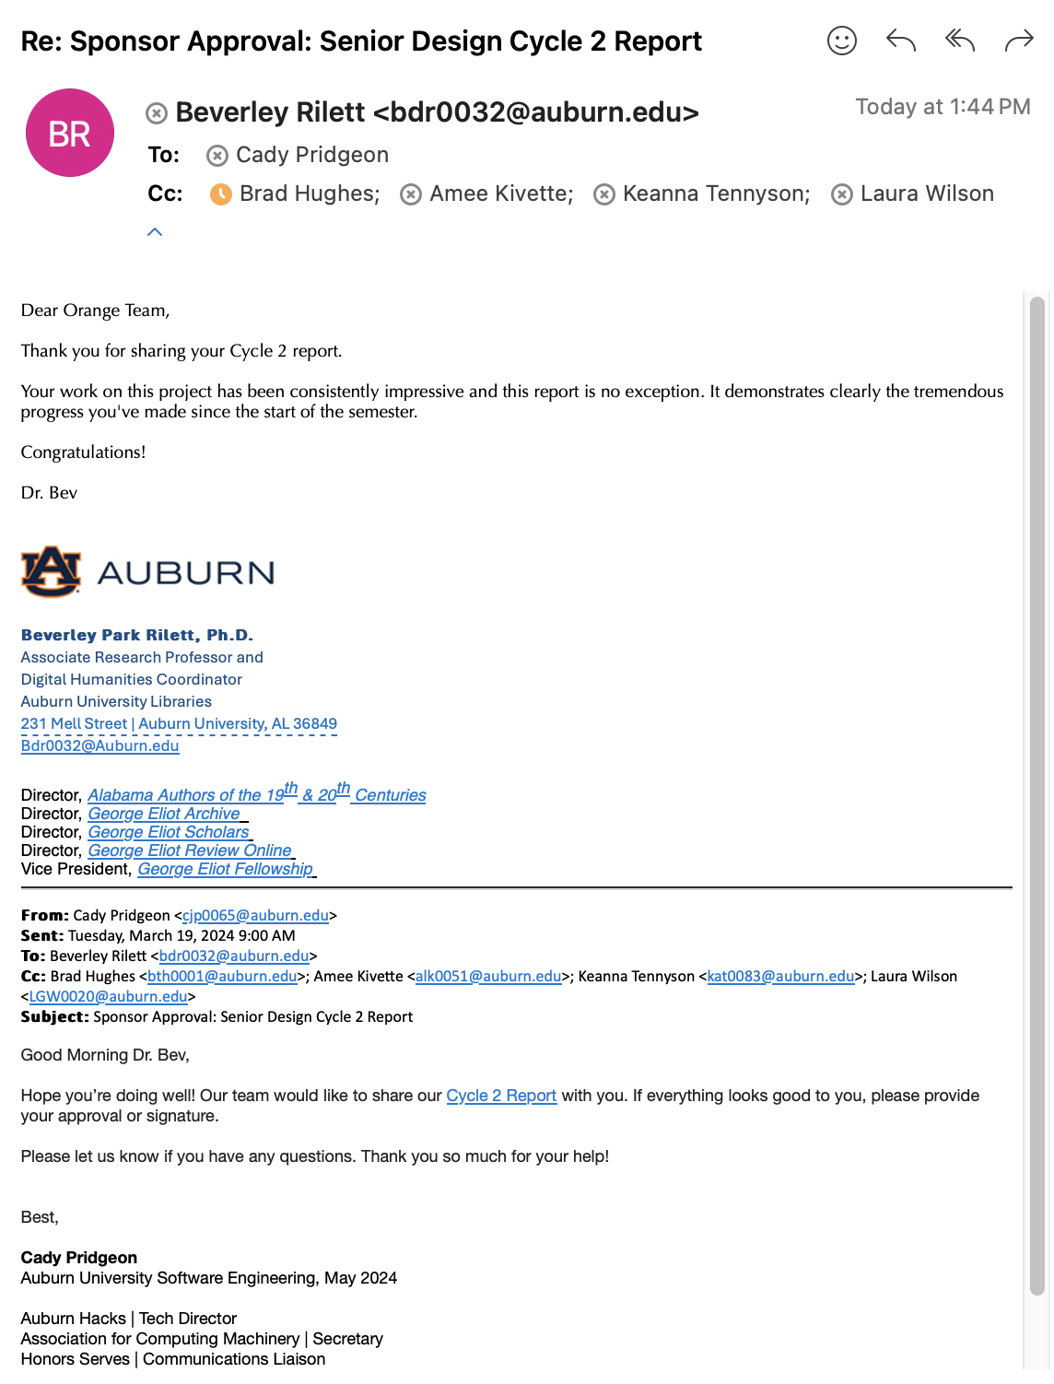

**Figure 37. Email correspondence containing sponsor approval from Dr. Beverley Rilett**

# References • Cady Pridgeon

[1] Cady Pridgeon, Amee Kivette, Keanna Tennyson, and Laura Wilson. 2024. *Visualization: Architectural Spike*. COMP 4710 Senior Design Project 3 Team Orange Architectural Spike Written Report. Auburn University, Auburn, AL.

[2] Cady Pridgeon, Amee Kivette, Keanna Tennyson, and Laura Wilson. 2024. *Visualization: Cycle 1*. COMP 4710 Senior Design Project 3 Team Orange Architectural Spike Written Report. Auburn University, Auburn, AL.

# 

# A. Appendix • Keanna Tennyson, Cady Pridgeon

## A.1. Meeting Minutes

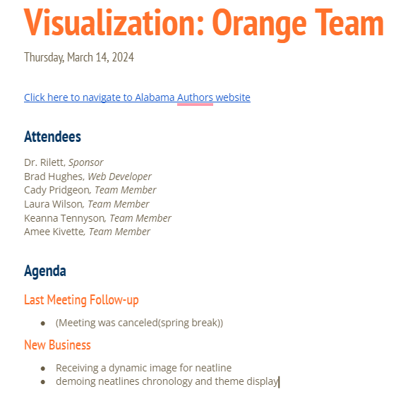

**Figure A1. March 14, 2024 Meeting Notes**

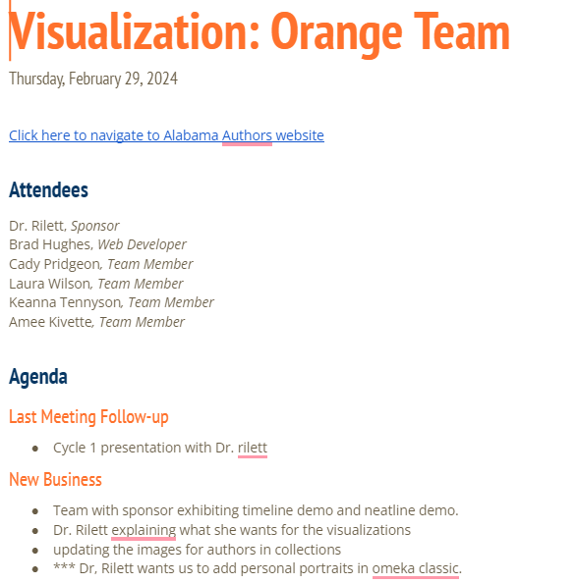

**Figure A2. February 29, 2024 Meeting Notes**

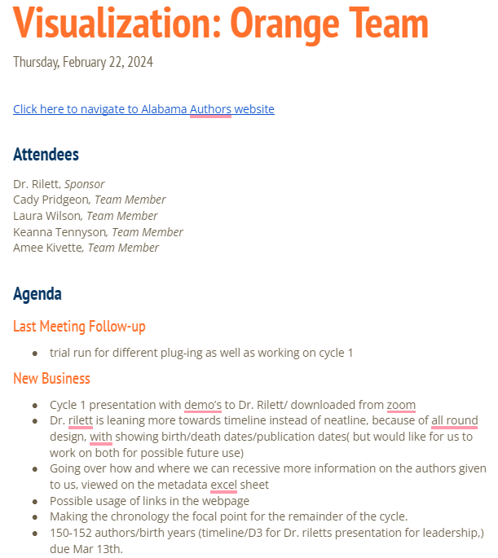

**Figure A3. February 22, 2024 Meeting Notes**

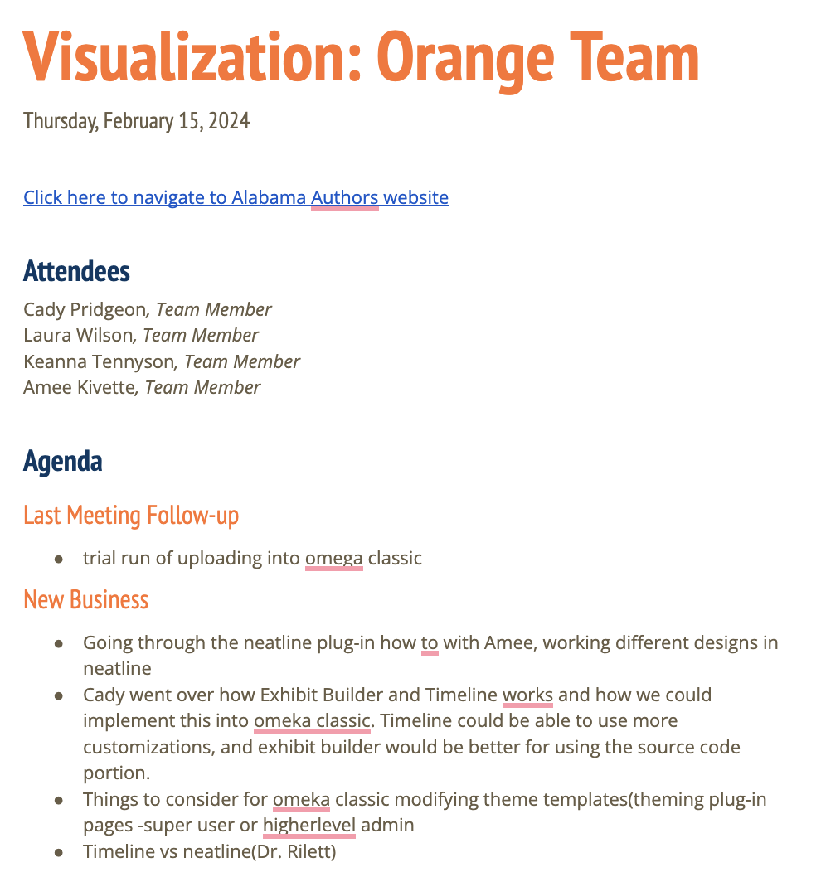

**Figure A4. February 15, 2024 Meeting Notes**

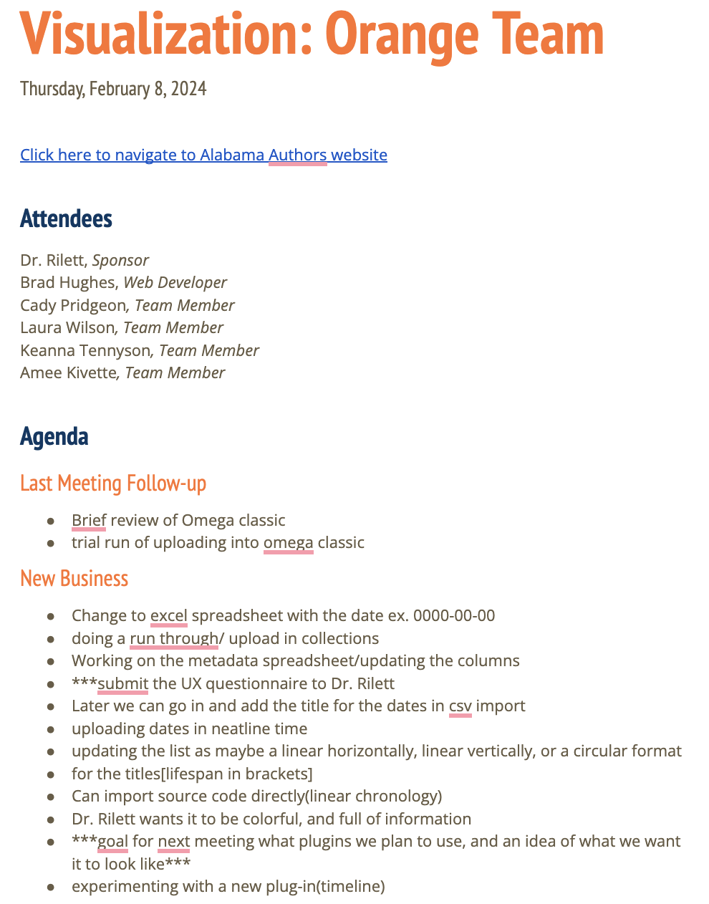

**Figure A5. February 8, 2024 Meeting Notes**

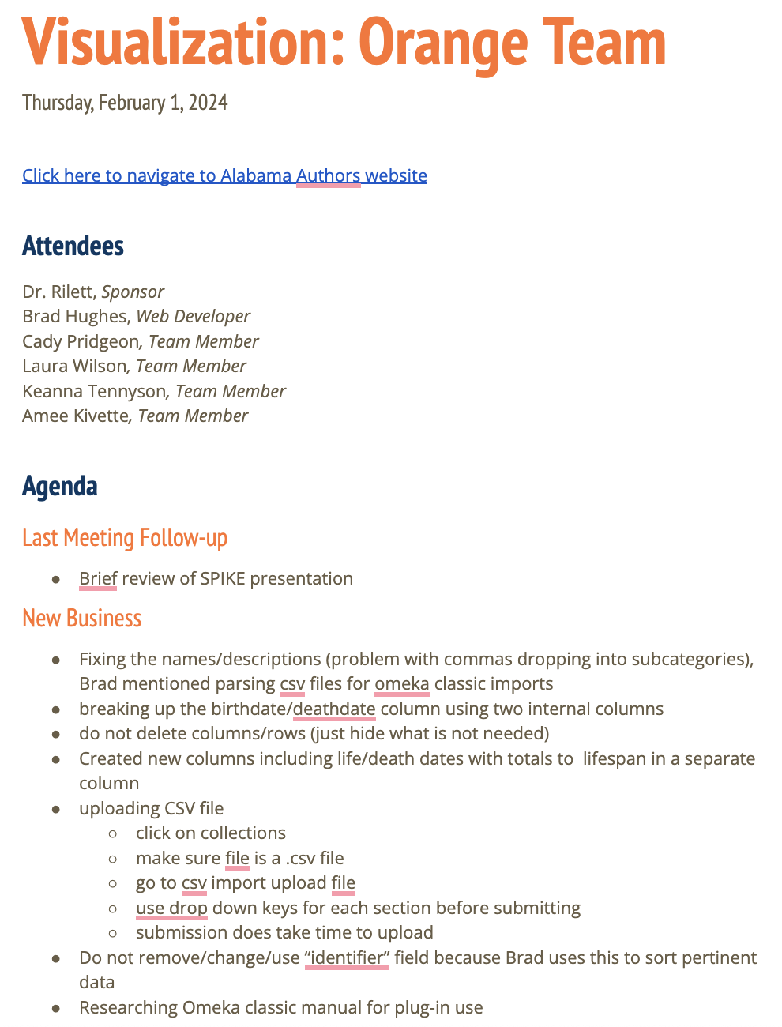

**Figure A6. February 1, 2024 Meeting Notes**



**Figure A7. January 25, 2024 Meeting Notes**

## 

## A.2. Correspondence

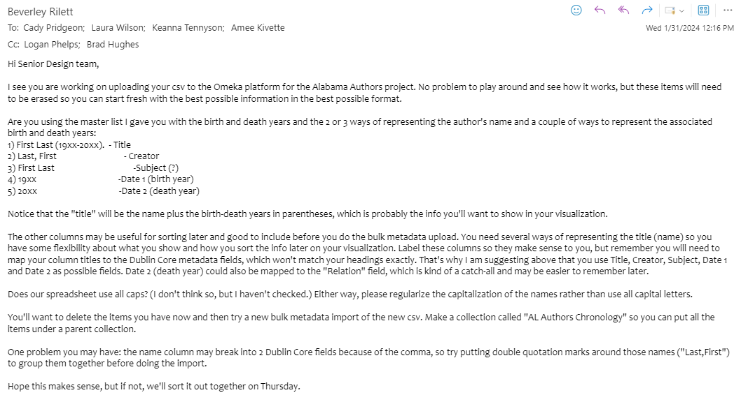**Figure A8. Email from Dr. Rilett to Team on January 31, 2024**

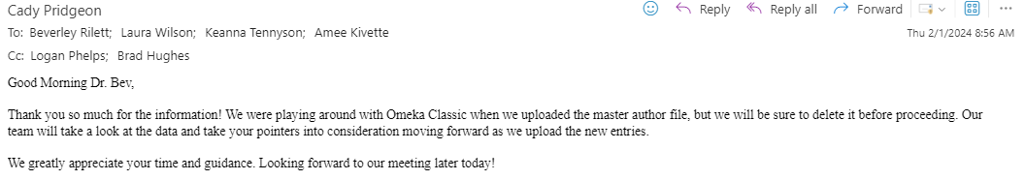

**Figure A9. Email from Cady Pridgeon to Dr. Rilett on February 1, 2024**

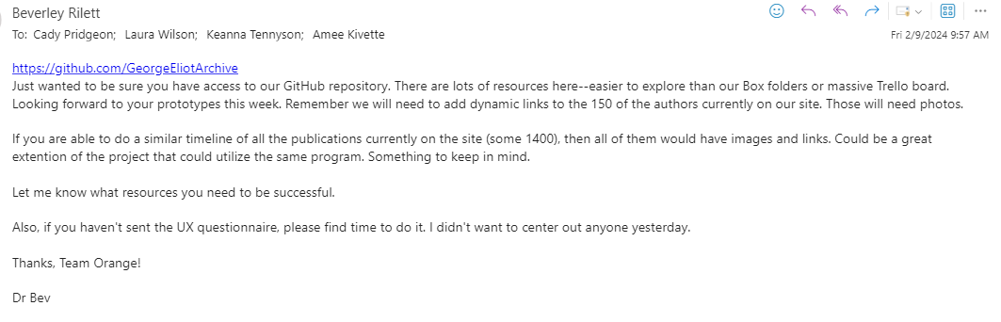

**Figure A10. Email from Dr. Rilett to Team on February 9, 2024**

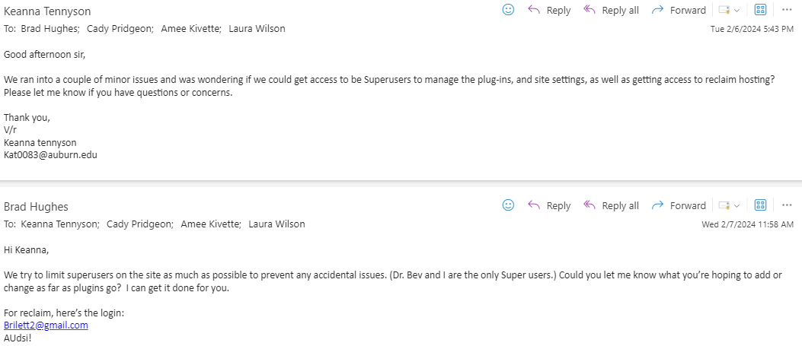

**Figure A11. Emails between Keanna Tennyson and Brad Hughes on February 6-7, 2024**

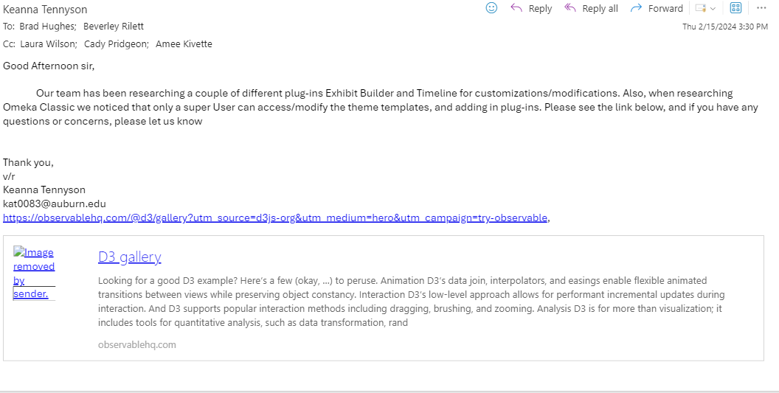**Figure A12. Email from Keanna Tennyson to Brad Hughes on February 15, 2024**

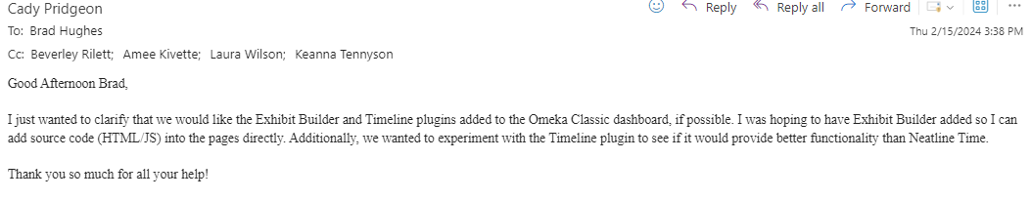

**Figure A13. Email from Cady Pridgeon to Brad Hughes on February 15, 2024**

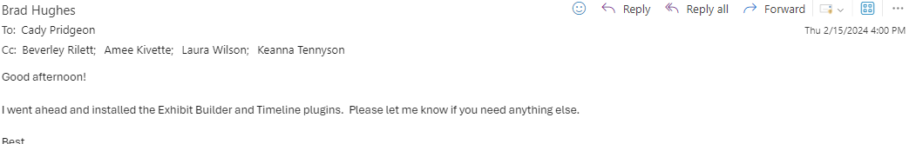**Figure A14. Email from Brad Hughes to Team on February 15, 2024**

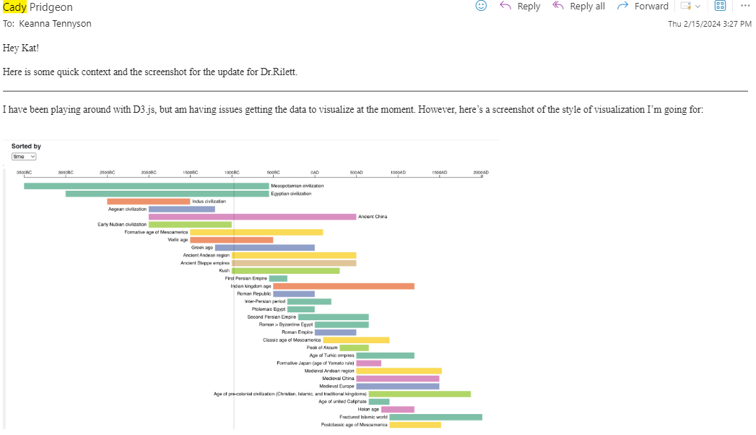

**Figure A15. Email from Cady Pridgeon to Keanna Tennyson on February 15, 2024**

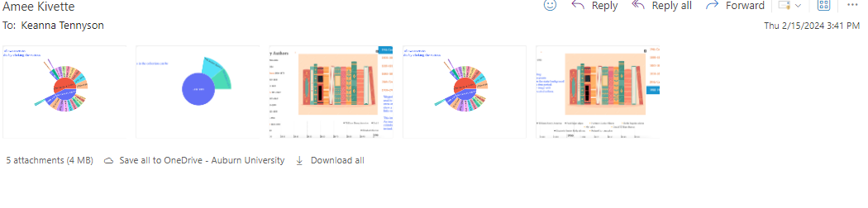

**Figure A16. Email from Amee Kivette to Keanna Tennyson on February 15, 2024**

## A.3. Project Resources

The Alabama Authors website is accessible at <https://alabamaauthors.org/>.

The initial D3.js data visualization website is accessible at <https://cadypridgeon.github.io/al-authors-chronology/>.

The current D3.js data visualization website is accessible at <https://cadypridgeon.github.io/al-authors-150/>.

## A.4. Source Code

Please find the D3.js data visualization source code at <https://github.com/cadypridgeon/al-authors-chronology> and <https://github.com/cadypridgeon/al-authors-150>.

## A.5. Version Description

## Neatline

**Version 2.0**

For the current solution on Omeka Classic, the Neatline plugin offers a timeline and chart wheel heatmap for data interaction.

Key Features:

* Neatline timeline functionality for viewing authors
* Neatline heatmap functionality for viewing author density on a calendar wheel
* Book publication support

Bugs & Issues:

* Neatline requires tedious manual data entry that remains in progress

**Version 1.0**

For the current solution on Omeka Classic, the Neatline, Neatline Time, and Timeline plugins offer three various timeline visualizations of the complete Alabama Authors data.

Key Features:

* Neatline functionality for viewing authors by period
* Neatline functionality for viewing author name, lifespan, photo, and details page from the visualization
* Neatline Time and Timeline secondary functionality available

Bugs & Issues:

* Neatline Time and Timeline produce slow and limited visualizations
* Neatline uses a placeholder image for now
* Neatline requires manual data entry

## D3.js

**Version 2.0**

For the current solution using D3.js, the visualization processes the complete Alabama Authors data and the Alabama Authors Collection data in an interactive format.

Key Features:

* Zoomable chart to highlight the magnitude of data
* Hover states available for additional author information
* Provides sort and filter capabilities to customize data shown
* Allows users to switch between the complete author data and collection data with the view dropdown
* Uses color-blind-friendly colors
* Produces an interesting and modern visualization that is consistent with the Alabama Authors website branding
* Available on the Alabama Authors website

Bugs & Issues:

* The visualization is not yet responsive for mobile devices
* Accessibility features need to be implemented

**Version 1.0**

For the current solution using D3.js, the visualization processes the complete Alabama Authors data in an interactive format.

Key Features:

* Zoomable chart to highlight the magnitude of data
* Hover states available for additional author information
* Produces an interesting and modern visualization that is sortable

Bugs & Issues:

* Does not interface with the Omeka Classic system
* Some sort functionality is not bug-free
* Photos and detail links require manual data entry

## A.6. Current Cycle Documents

Please find the Cycle 2 presentation slides at <https://docs.google.com/presentation/d/1BUPIShwrFnwWWUDzZcTAvFOQQ731H3_nNHumqHZjLSs/edit?usp=sharing>.

Please find the Cycle 2 video demonstrations at <https://drive.google.com/drive/folders/1IHJf8IYzC4XcsCnkPmdU6jpZZ9XzUQ-C?usp=sharing>.

Please find the Cycle 2 status reports at <https://drive.google.com/drive/folders/1iZR-7obuMmwjZ0oOtKSQhc1YEVrUqdAp?usp=sharing>.

## A.7. Previous Cycle Documents

**Cycle 1**

* Written Report:

<https://docs.google.com/document/d/13utuDzI2PMMl9jcutPWI36sCGTfq8n8vMiURflwEfS4/edit?usp=sharing>

* Presentation Slides:

<https://docs.google.com/presentation/d/1dCdi89m2akV9EBTnaWofOgszXSbSbXZUkI8wMOTK7DE/edit?usp=sharing>

* Video Demonstrations:

<https://drive.google.com/drive/folders/1Z0F39J37Z6FhKg9cdXBwnPmedI69c-tY?usp=sharing>

* Status Reports:

<https://drive.google.com/drive/folders/1YI2GOD4i00iMbaioBki-ftXrqV9SysNa?usp=sharing>

**Architecture Spike**

* Written Report: <https://docs.google.com/document/d/1tvpr4m6h3w0GzWS8NE92hoHThVsdL3VSgvgN68JwWhA/edit?usp=sharing>
* Presentation Slides: <https://docs.google.com/presentation/d/1CTxNb0ZgCglFvZK_e8i7icP9M2q5okNBbJfL5kEeI-k/edit?usp=sharing>